2021
Stakeholder Engagement Plan
Georgia Emergency COVID-19 Response Project
With Additional Financing for vaccines

April 1, 2021

Contents
1. Introduction / Project Description 4
2. Stakeholder identification and analysis 7
2.1 Methodology 7
2.2 Affected Parties 8
2.3 Other Interested Parties 9
2.4 Vulnerable individuals or groups 10
3. Stakeholder Engagement Program 10
3.1 Summary of stakeholder engagement done during project preparation 10
3.3 Summary of project stakeholder needs and methods, tools and techniques for stakeholder engagement 11
3.4 Stakeholder Engagement Plan 12
3.5 Proposed strategy for information disclosure 16
3.6 Future of the project 18
3.7 Proposed strategy to incorporate the views of vulnerable groups 18
4. Resources and Responsibilities for implementing stakeholder engagement activities 19
4.1. Resources 19
4.2. Management functions and responsibilities 19
5. Grievance Redress Mechanism 20
5.1 Description of GRM 20
5.2 Redressing of Grievances by Civil Works Contractor (CWC) 21
5.3 Redress of Grievances by healthcare and quarantine facilities 22
5.3.1 Receiving and registration of complaints at MoILHSA and/or its Subordinated Entities 23
5.3.2 Receiving and resolution of complaints in SSA 23
5.3.3 Receiving and resolution of complaints in SESA 25
5.3.4 MoILHSA 27
5.3.5 PIU 29
Formation of Grievance Redress Committee 29
5.4 Disclosure of Grievance Redress Procedure 29
5.5 Database 29
5.6 Reporting 29
5.7 World Bank Grievance Redress System 31
6. Monitoring and Reporting 31

  - abbreviations and Acronyms
AF | Additional Financing
AIIB | Asian Infrastructure and Investment and Bank
EU | European Union
ESCP | Environmental and Social Commitment Plan
ESF | Environmental and Social Framework
ESMF | Environmental and Social Management Framework
ESMP | Environmental and Social Management Plan
ESHS | Environmental, Social, Health and Safety
ESS | Environmental and Social Standard
GoG | Government of Georgia
GRM | Grievance Redress Mechanism
IBRD | International Bank for Reconstruction and Development
ICT | Information and Communications Technology
ILO | International Labor Organization
LEPL | Legal entity under public law
MIA | Ministry of Internal Affairs of Georgia
MoILHSA | Ministry of Internally Displaced People from the Occupied Territories, Labor, Health and Social Affairs
MoD | Ministry of Defense of Georgia
Geostat | National Statistics Office of Georgia
PPE | Personal Protective Equipment
SBCC | Social and Behavior Change Communication
SEA | Sexual Exploitation and Abuse
SH | Sexual Harassment
SEP | Stakeholder Engagement Plan
SESA | State Employment Support Agency
SSA | Social Service Agency
TSA | Targeted Social Assistance
WHO | World Health Organization

Introduction / Project Description

An outbreak of the COVID-19 disease (COVID-19) caused by the 2019 novel COVID-19 (SARS-CoV-2) has been spreading rapidly across the world since December 2019, following the diagnosis of the initial cases in Wuhan, Hubei Province, China. Since the beginning of March 2020, the number of cases outside China has increased thirteen fold and the number of affected countries has tripled. On March 11, 2020, the World Health Organization (WHO) declared a global pandemic as the COVID-19 rapidly spreads across the world. As of April 10, 2020, the outbreak has resulted in an estimated 18,824,259 cases and 707,905 COVID-19 deaths in 210 countries. In Georgia, as of August 6, 2020 there have been recorded 1206 cases of COVID-19, 987 recovery and 17 deaths.
In response to the emerging epidemic situation and to scale up emergency response mechanisms in all sectors and preventing COVID-19 from moving to the community transmission stage and subsequently into an epidemic the Government of Georgia (GoG) took the first important steps already in early January 2020. The Decree 164 on “Approval of Measures to Prevent the Possible Spread of the New Coronavirus in Georgia and Approval of an Emergency Response Plan for Cases Caused by COVID-19” had been adopted on January 28, 2020 and the national multi sectoral committee established. According to the Emergency Response Plan, approved by the GoG, each line ministry and government entity has clearly defined roles and responsibilities at every stage of COVID-19 response.
On March 21, 2020 the Parliament of Georgia approved the declaration of a nationwide State of Emergency aimed to counter the global coronavirus pandemic. A number of non-pharmaceutical interventions (NPI) were enforced, nationwide, aimed at suppression of the virus in the communities. These NPI consisted, progressively, but were not limited to: closure of all educational institutions and many public venues, including gyms, museums, and theaters, malls, shops, bars and restaurants. Strict transportation restrictions were introduced, including the suspension of air and rail traffic, as well as borders with neighboring countries, Armenia, Azerbaijan, Turkey and Russia were closed. Checkpoints have been set up in Tbilisi, Batumi, Kutaisi, Rustavi, Poti, Zugdidi and Gori for screening and early case detection as part of the global prevention measures. Additional quarantine measures followed later: Restrictions on the movement of persons by foot or by means of transport for the period of emergency, with daily curfew between 09:00 pm - 06:00 am; Prohibition of public and mass events, and meetings and social gatherings limited to not more than 3 persons; Shifting schools and universities to online mode of practice and distance-learning. In addition, starting from April 17, additional lockdown measures were introduced prohibiting all transport movement except for delivery cars and cargo transport. All COVID-19 related medical treatment provided was free of charge for all patients in need, whether or not covered by the health insurance.
The lockdown and closure of all non-essential business activities, work and travel restrictions within and outside the country, closure of borders and imposed curfews combined have caused slow-down in economic activity and growth, increasing the risks of poverty and unemployment.
In the absence of immediate social protection measures aimed to preserve income of the most vulnerable, the COVID-19 health crisis is likely to transpose into a crisis effects of which are likely to fall disproportionately to households with inadequate coping strategies or safety nets. The government is yet to consider short-term strategies aimed to mitigate the adverse effects such as: ensuring adequate access to health care (particularly for at-risk groups), alleviating food shortages and compensating for reduced and/or lost income through appropriate social security transfers.
To stabilize the existing situation and save more lives until an etiotropic drug against COVID-19 is developed, the optimal solution would be to introduce and administer safe and effective vaccines against COVID-19, which is ultimately the key to containing an epidemic.

An Interagency Coordination Commission chaired by Georgia’s Minister of Internally Displaced Persons from the Occupied Territories, Labor, Health and Social Affairs (the MoILHSA) was established to facilitate the development and implementation of a COVID-19 vaccination policy in Georgia.
The preparation of the vaccination implementation plan has been coordinated by the National Center for Disease Control and Public Health (NCDC). To support Georgia in implementation of
COVID-19 Vaccine National Deployment Plan approved by the Governmental Resolution #67 as of January 21, 2021 the World Bank will provide Additional Financing (AF) to Georgia in amount of 34.5 million USD within the scope of the Georgia Emergency COVID-19 Project.
The proposed Georgia Emergency COVID-19 Project’s (P173911) objective is to prevent, detect and respond to the threat posed by COVID-19 and strengthen national systems for public health preparedness in Georgia. The AF will finance the procurement and transport of vaccines.

The project comprises of the following components:
Component 1. Emergency COVID-19 Response

- Sub-component 1.1: Case Detection and Confirmation
- Sub-component 1.2: Health System Strengthening for Case Management
- Subcomponent 1.3 (AF): support to the country for implementing National Vaccine Deployment Plan for COVID-19 vaccination

Component 2. Temporary income support for poor households and vulnerable individuals affected by COVID-19 pandemic
- Subcomponent 2.1: Scale up of the Targeted Social Assistance (TSA) program for extreme poor households.
- Subcomponent 2.2: Temporary cash transfers to informal workers
- Subcomponent 2.3: Temporary unemployment benefits

Component 3. Project Management and Monitoring

Component 1: Emergency COVID-19 Response
Sub-component 1.1: Case Detection and Confirmation
This sub-component will help to strengthen public health laboratories and epidemiological capacity for early detection and confirmation of cases. It will support the strengthening of diseases surveillance systems and the capacity of the selected public health laboratories to confirm cases by financing medical supplies and equipment. It will include personal protection equipment (PPE) and hygiene materials, COVID-19 test kits, laboratory reagents, polymerase chain reaction equipment, and specimen transport kits. It will also include financing for quarantine facilities, which will help to identify and monitor people with high probability for infection.
Sub-component 1.2: Health System Strengthening for Case Management
The Project aims to contribute to the strengthening of health system preparedness, improve the quality of medical care provided to COVID-19 patients, and minimize the risks for health personnel and patients. These objectives will be achieved through the procurement of essential medical goods, rapid conditioning of designated public health facilities, which includes cost of standby healthcare facilities and rental of private Hospitals for COVID patient treatment, and financing of COVID-19 related treatment costs. This sub-component will also provide equipment, drugs and medical supplies. The Project will finance PPE and hygiene materials for health workers and other staff who may be at high risk of exposure to COVID-19, including individuals working in quarantine facilities and border posts. In addition, this sub-component will support capacity improvements in designated public facilities, including Rukhi hospital, which is located near Abkhazia and serves a large internally displaced population and Batumi hospital. This sub-component will finance intensive care units (ICUs) and beds in the designated public hospitals, as well as minor repairs, such as remodeling ICUs and increasing the availability of isolation rooms, and other capacity needs to improve service delivery for COVID-19. The Project will also finance case management and treatment of COVID-19 patients in public and private facilities by supporting the reimbursement of claims by the Social Services Agency (SSA) for COVID-19 related services. To ensure sustainability, the Project will support consulting services to revise the payment methods for health care services, including tariff setting for COVID-19. It will also finance compensation in the form of a global budget to public and private facilities for idle capacity and ensure standby readiness to provide COVID-19 care. This sub-component will support case management for non-severe cases in non-medical settings (e.g. hotels temporarily rented for this purpose) for those individuals who cannot self-isolate at home and will finance ambulances to support urgent transportation of patients across the hospital network to designated reference facilities. In addition, the stressful pandemic situation identified the urgent necessity to improve reimbursement system in Universal Health Care, especially for those actively involved in COVID-19 case management. The project will finance the one of costs related to reducing the period between service provision and payment.
Sub-component 1.3 (AF): support to the country for implementing National Vaccine Deployment Plan for COVID-19 vaccination:
This subcomponent provides financing for vaccination. The project will finance procurement of 2.5 million dose of vaccines from FDA/EMA approved manufacturers (enclosed in WHO EUL/PQ database) and associated vaccine roll-out needs. The project does not involve activities for development of the management system for vaccination as it already exists in the country and their activities will be adapted to COVID-19 vaccination procedures. For this government of Georgia has already developed COVID-19 Vaccine National Deployment Plan and COVID-19 Vaccine National Deployment Plan and Immunization Management Rules.
Recently, as agreed between the Parties, 34.5 million USD will be made available to the Government of Georgia and the Ministry, as part of the COVID-19 Strategic Preparedness and Response Program (SPRP) Additional Financing (AF) for World. The Objective of the SPRP is to prevent, detect and respond to the threat posed by COVID-19 and strengthen national systems for public health preparedness, and the AF will allow to significantly expand Bank support to the country for implementing National Vaccine Deployment Plan for COVID-19 vaccination, officially endorsed in January 2021.
Under the Sub-Component, an effective and safe COVID-19 vaccine(s) will be made available, along with supplies and capacities, including communication that is strategically important for successful attainment of the ambitious goals of the Plan.
Target population groups in Georgia for 2021 have been selected for gradual coverage according to relevant international recommendations and Georgia’s epidemiological characteristics. The selection of these groups was based upon the recommendations of ETAGE, and was aimed primarily at maintaining vital health services and reducing morbidity and mortality in high-risk groups. The selected groups were reviewed and recommended by the National Immunization Technical Advisory Group (NITAG) of Georgia on December 12, 2020.

Targeting criteria and implementation plans for immunization are as follows:

- Stage 1: this stage would target health workers, other essential workers, and the most vulnerable populations, including the elderly. These targeted groups are estimated to account for 60 percent of the population: I. (a) health care workers (65 percent or 46,420 people); Beneficiaries and staff of a long-term care facilities (60 percent or 1,560 people); Elderly population over the age of 75 (60 percent or 136,080 people); (b) Elderly population over the age of 65-74 (60 percent or 197,510 people);

- Stage 2: II (a) Essential services providers (estimated 60 percent or 108,224 persons); Population between 55-64 years (estimated 60 percent or 287,040 persons); (b) People with chronic diseases, age group 18-54 years (estimated 60 percent or 53,640 person);

- Stage 3: Other population groups (estimated 60 percent or 860,740 persons).
Component 2. Temporary income support for poor households and vulnerable individuals affected by the health measures to contain the COVID-19 outbreak
Subcomponent 2.1: Scale up of the Targeted Social Assistance (TSA) program for extreme poor households
This sub-component will finance the natural expansion of the TSA program to support households negatively impacted by the health measures adopted to contain the outbreak and the resulting economic downturn. By design, the program targets extreme poor households based on a Proxy Means Test (PMT) scoring formula which is partially shock responsive. It is expected that about 35,000 new households will apply and be eligible to the TSA program in a scenario where 20 percent of formal wage workers will lose their jobs and where wage workers staying in their jobs will see their labor income reduced by 20 percent. The benefit amounts remain the same. The implementation of this sub-component will rely on the existing mechanism by which the SSA will determine and verify the eligibility and will contract with Liberty Bank to make payments. Application procedures and all payments are cash-free and the implementation processes have been already simplified and adapted to minimize the risk of contagion in compliance with the regulations on social distancing.
Subcomponent 2.2: Temporary cash transfers to informal workers
This sub-component will support the introduction of a temporary (cash) one-off 300 GEL benefit targeted to vulnerable households dependent on informal and occasional work, in particular, self-employed individuals of different categories will receive a one-off assistance. Meaning that individual entrepreneurs registered at the Revenue Service and any individual who will submit a document issued by a taxpayer registered in Georgia (except documents issued by physical persons who are not entrepreneurs) proving that the individual carried out an economic activity and/or received income in the 1st quarter of 2020 will be eligible.
The one-off benefit will be on-demand and provide a benefit of about 300 GEL per person who lost income due to the negative impacts because of measures adopted to contain the outbreak and the resulting economic downturn. Eligible citizens will be registered at the online registration platform (https://compensation.moh.gov.ge/) and providing personal information. The eligibility determination and verification processes will be carried out by SESA based on revenue service information. Benefits will be transferred by SESA to the private bank accounts of the beneficiaries provided by them personally (while registering).
Subcomponent 2.3: Temporary unemployment benefits for formal workers
This sub-component will support the introduction of a temporary unemployment assistance benefit for formal wage workers who lose their jobs because of containment measures taken to contain the spread of the coronavirus. A flat benefit of 200 GEL per month will be provided to private sector workers who are laid off as a result of COVID-related restrictions and economic lockdown of non-essential businesses. The benefit amount is commensurate to the cost of living: the monthly social pension is set at 220 GEL per person per month (old age pension) as a comparison. The duration of the unemployment assistance benefit is for a period up to 6 months. Simulations on Labor Force Survey 2018 show that about 300,000 formal wageworkers will be laid off (assuming a dismissal rate of 50 percent). The Revenue Service will compile a list of laid off workers based on companies’ declarations and on the cross-verification with the payroll income database. The Revenue Service will submit the list of unemployed and their bank account details to SESA who will further verify eligibility. State Employment Support Agency (SESA) will proceed with the payment to respective bank accounts as provided by the Revenue Service.
Component 3. Project management and monitoring
This component will support project implementation for the overall administration of the Project, including procurement, financial management, as well as regular monitoring and reporting on project implementation (and required fiduciary assessments). A Project Implementation Unit (PIU) is established in MoILHSA, which comprises 6 consultants hired to cover the PIU key functions given the overwhelming scope of response to COVID-19 and the urgency of actions to be taken by all parties. These include consultants for health, procurement, financial management, social and environmental standards, and a consultant to support the overall coordination, monitoring, and evaluation of the Project activities. Other consultants can also be hired as needed during the Project implementation. As such, the MoILHSA will be responsible for the overall administration, fiduciary functions, environmental and social aspects, communication and outreach for both components 1 and 2.
The Georgia Emergency COVID-19 Project is being prepared under the World Bank’s Environment and Social Framework (ESF). As per the Environmental and Social Standard (ESS) 10 on “Stakeholder Engagement and Information Disclosure”, the implementing agency (SESA) under MoILSHA, should provide stakeholders with timely, relevant, understandable and accessible information and consult with them in a culturally appropriate manner, which is free of manipulation, interference, coercion, discrimination and intimidation.
The overall objective of this Stakeholder Engagement Plan (SEP) is to define a program for stakeholder engagement, including public information disclosure and consultation, throughout the entire project cycle. The SEP outlines the ways in which the project team will communicate with stakeholders and includes a mechanism by which people can raise concerns, provide feedback, or make grievances about project and any activities related to the project. The involvement of the local population is essential to the success of the project in order to ensure smooth collaboration between project staff and local communities and to minimize and mitigate environmental and social risks related to the proposed project activities. In the context of infectious diseases, broad, culturally appropriate, and adapted awareness raising activities are particularly important to properly sensitize the communities to the risks related to infectious diseases.

Stakeholder identification and analysis
Project stakeholders are defined as individuals, groups or other entities who:
- are impacted or likely to be impacted directly or indirectly, positively or adversely, by the Project (also known as ‘affected parties’); and
- may have an interest in the Project (‘interested parties’). They include individuals or groups whose interests may be affected by the Project and who have the potential to influence the Project outcomes in any way.
Cooperation and negotiation with the stakeholders throughout the Project development often also require the identification of persons within the groups who act as legitimate representatives of their respective stakeholder group, i.e. the individuals who have been entrusted by their fellow group members with advocating the groups’ interests in the process of engagement with the Project. Community representatives may provide helpful insight into the local settings and act as main conduits for dissemination of the Project-related information and as a primary communication/liaison link between the Project and targeted communities and their established networks. Verification of stakeholder representatives (i.e. the process of confirming that they are legitimate and genuine advocates of the community they represent) remains an important task in establishing contact with the community stakeholders. Depending on the different needs of the identified stakeholders, the legitimacy of the community representatives can be verified by checking with a random sample of community members using techniques that would be appropriate and effective considering the need to also prevent coronavirus transmission.

Methodology
In order to meet best practice approaches, the project will apply the following principles for stakeholder engagement. This will be ensured through the electronic platform:
- Openness and life-cycle approach: public consultations for the project(s) will be arranged during the whole life-cycle, carried out in an open manner, free of external manipulation, interference, coercion or intimidation;
- Informed participation and feedback: information will be provided to and widely distributed among all stakeholders in an appropriate format; opportunities are provided for communicating stakeholders’ feedback, for analyzing and addressing comments and concerns;
- Inclusiveness and sensitivity: stakeholder identification is undertaken to support better communications and build effective relationships. The participation process for the projects is inclusive. All stakeholders are encouraged to be involved in the consultation process, to the extent the current circumstances permit. Equal access to information is provided to all stakeholders. Sensitivity to stakeholders’ needs is the key principle underlying the selection of engagement methods. Special attention is given to vulnerable groups, in particular women, youth, elderly, disabled, and the sensitive and diverse cultural and ethnic groups.
For the purposes of effective and tailored engagement, stakeholders of the proposed project can be divided into the following core categories:
- Affected Parties – persons, groups and other entities within the Project Area of Influence (PAI) that are directly influenced (actually or potentially) by the project and/or have been identified as most susceptible to change associated with the project, and who need to be closely engaged in identifying impacts and their significance, as well as in decision-making on mitigation and management measures;
- Other Interested Parties – individuals/groups/entities that may not experience direct impacts from the Project but who consider or perceive their interests as being affected by the project and/or who could affect the project and the process of its implementation in some way; and
- Vulnerable Groups – persons who may be disproportionately impacted or further disadvantaged by the project(s) as compared with any other groups due to their vulnerable status, and that may require special engagement efforts to ensure their equal representation in the consultation and decision-making process associated with the project.

2.2 Affected Parties
Affected Parties include local communities, community members and other parties that may be subject to direct impacts from the Project. Specifically, the following individuals and groups fall within this category:
- COVID-19 infected people in hospitals and their families & relatives;
- People in quarantine/isolation centers and their families & relatives;
- Workers in quarantine/isolation facilities, hospitals, diagnostic laboratories;
- People at higher risk of contracting COVID-19 (e.g. tourists, tour guides, hotels and guest house operators & their staff, associates of those infected inhabitants of areas where cases have been identified)
- Public/private health care workers (doctors, nurses, public health Inspectors, midwives, laboratory technicians/staff, all types of workers in quarantine/isolation facilities, hospitals, diagnostic laboratories, service of emergency assistance);
- People at COVID-19 risk with underlying conditions (elderly 65+, people leaving with AIDS/HIV, people with chronic medical conditions, such as diabetes and heart disease),
- Beneficiaries and staff of a long-term care facilities:
- Essential services providers:
- Population between 55-64 years;
- People with chronic diseases, age group 18-54 years ;
- General population eligible to vaccination

- Travelers, inhabitants of border communities, etc.;
- Civil work contractors involved in small repairs or installation of equipment at hospital premises, laboratories, quarantine centers, or other medical facilities;
- Law enforcement authorities and their uniformed staff (e.g. Police, Army) involved in enforcing quarantine measures;
- Staff involved in transport and logistics related to the project site.
- Local Government administrations in affected regions
- MoIHLSA officials and the staff actively involved in the project implementation;
- Persons at risk of losing employment as a result of COVID-19 economic impacts;
- Business owners losing income or closing down as a result of COVID-19 related economic downturn;
- Business owners contemplating lay-off of workers due to declining revenues;
- Tourism sector businesses including travel companies, travel agents, hotels, individual service providers;
- Employees of SSA and SESA / social workers closely involved in delivery of services and benefits to project beneficiaries;
- Staff involved in transport and logistics, financial, or other services related to the delivery of social and other possible benefits.
- Given the package of measures already announced and adopted by the government, the impacts of COVID-19 are likely to influence the following groups in Georgia: (i) households and individuals relying on vulnerable employment (defined as casual labor, temporary work and informal self-employment), who lose their jobs due to the social distancing and or quarantines that causes closure of viable businesses leading to a sudden loss of livelihood; (ii) formal workers in all sectors, especially those who work in the tourism, service (transportation and retail) and trade-related sectors, who have been already negatively impacted by the economic lockdown, (iii) poor and near poor households who will have less margin to cope with potential price increases. These groups are considered vulnerable to the impacts of the COVID-19 pandemic and will benefit from the social protection measures.

2.3 Other Interested Parties
The project stakeholders also include parties other than the directly affected communities, including:
- The public at large;
- Community based organizations, national civil society groups and NGOs;
- Religious organizations;
- Goods and service providers involved in the project’s wider supply chain;
- Governmental institutions;
- Interested international Organizations – UN, EU, NGOs, and Diplomatic mission;
- Media and other mass-information groups, including social media;
- National health/professional associations and academia (Health Universities, and other academic institutions);
- Interested businesses and business associations, chambers of commerce;
- Schools, universities and other education institutions closed down due to the virus;
- Public transport workers, including taxi and mini-bus drivers.
- Environment and social protection state and non-state actors, interested in mitigating risks associated with the pandemic
- Ombudsman and other human rights defenders / bodies, interested in safeguarding equality in the response and related phases.

2.4 Vulnerable individuals or groups
It is particularly important to understand whether project impacts may disproportionately fall on vulnerable individuals or groups, who often do not have a voice to express their concerns or understand the impacts of a project. The project should ensure that awareness raising, and stakeholder engagement activities are adapted to take into account such groups’ particular needs, concerns and cultural sensitivities and to ensure their full understanding of project activities and benefits. The vulnerability may stem from a person’s gender, age, health condition, disability, ethnic/language background, economic deficiency and financial insecurity, or other circumstances, for example being a single parent, being a caregiver of elderly or persons with disabilities, etc. Engagement with the vulnerable groups and individuals often requires tailored measures and assistance to facilitate their participation in the project-related activities so that their awareness of and input to the overall process are commensurate to those of the other stakeholders.

Within the Project, the vulnerable or disadvantaged groups include and are not limited to the following:

- Elderly,
- Individuals with chronic diseases and pre-existing medical conditions; also, mental health issues.
- Persons with disabilities,
- Persons residing in and employed in state institutions/boarding houses for persons with disabilities, public orphanages and nursing homes,
- Poor and vulnerable households, including recipients of targeted social assistance or other social transfers,
- Internally displaced persons and refugees,
- Pregnant women,
- Women, girls and female headed households,
- Children,
- Daily wage earners and persons employed in informal, temporary, seasonal jobs,
- Those living below poverty line,
- Unemployed, Communities in remote, high mountainous and hard to reach areas ,
- Ethnic (particularly those who are not fluent in the national language), also religious and other minorities.
Vulnerable groups within the communities affected by the project will be further confirmed and consulted through dedicated means, as appropriate. Description of the methods of engagement that will be undertaken by the project is provided in the following sections.

2.5 Target Audience for COVID-19 vaccination program
Target audience to be addressed during the implementation of COVID-19 vaccination program include the following groups of affected and interested parties:
  - Those, engaged in the COVID-19 vaccination introduction process:
- Coordination Council
- NITAG members
- Ministry of Health and NCDC
- Regional and District Public Healthcare Centers
- Local Government
- Local and International Partners
  - Medical Service Providers and personnel (entire medical sector)
  - High risk-group representatives
- Beneficiaries and personnel of long-term care facilities
- Persons over 55
- People with chronic diseases (18-54 years old)
- Essential service providers, etc.
  - Parts of the population that are not included in first-stage groups (expectation management)
  - Stakeholders or influencers
- Policy makers and politicians
- Civil society
- Scientists, academics
- Non-Governmental Organizations
- Critical and negative groups
- Business sector
6. Mass media and social media
- Central and regional television (including channels in ethnic minority languages)
- Radio
- Press
- Social media groups and Influencers
- STOPCOV.ge
- MOH.gov.ge
- NCDC.ge
- Facebook, Instagram pages

Stakeholder Engagement Program

3.1 Summary of stakeholder engagement done during project preparation
The speed and urgency with which this project has been developed to meet the growing threat of COVID-19 in the country (combined with State of Emergency and the government restrictions on gatherings of people) has limited the project’s ability to develop a complete SEP before approval of the project by the World Bank. The initial SEP was developed and disclosed prior to project appraisal, as the starting point of an iterative process to develop a more comprehensive stakeholder engagement strategy and plan. The World Bank team, including Country Management Unit representatives of the World Bank office in Tbilisi, held a series of on-line meetings with the Government aimed at discussing the impact of the pandemic to the social sectors and economy and how the World Bank can help government in responding to the pandemic. The government sought the World Bank’s assistance in coping with the pandemic i.e. strengthening the public health sector preparedness and the social safety net response to the crisis. After these initial meetings the World Bank team had follow up meetings with the Ministry of Finance and the MoIHLSA, to discuss the scope of the operation. The World Bank and Government preparation teams received regular updates about the conclusions of the donor coordination meetings regarding the pandemic.
Communication Action Plan for Introduction of COVID-19 vaccine in Georgia (Appendix 3) was developed separately by NCDC as a part of the COVID 19 Vaccine Deployment Plan for GeorgiaThe main goal of the communication plan is to increase confidence, acceptance and demand for a COVID-19 vaccine using the approaches such as advocacy, communication, social mobilization, risk and safety issues communication, community and involvement, training, and crisis communication. The Plan was communicated with governmental entities involved in its implementation on January 16, 2021. COVID 19 Vaccine Deployment Plan for Georgia was approved by the Governmental Resolution #67 as of January 21, 2021. Implementation of the Communication Action Plan for Introduction of COVID-19 vaccine in Georgia will be carried out separately from this current SEP, but this SEP implementation will rely on and coordinate with the activities under the Communication Action Plan Implementation, which will be implemented by various government entities that are not implementing agencies under this Project.

3.2 Summary of stakeholder engagement during initial project implementation
To assist MoIHLSA in dealing with day-to-day responsibilities under the Georgia Emergency Covid-19 Project, the Project Implementing Unit (PIU) with relevant staff was established within the Ministry. PIU started work on update of Environmental and Social Standards documents. The following SEP in parallel with the Environmental and Social Management Framework (ESMF) has been developed under the project, disclosed and consulted on in compliance with the WB ESF requirements. Before disclosure, all entities under MoIHLSA participating in project implementation have been provided with draft SEP for review and feedback. A preliminary draft SEP was disclosed on the Ministry of Finance website in English and Georgian on April 19, 2020. A revised draft SEP and ESMF were disclosed on MoILHSA website both in Georgian and English on August 6, 2020 and were open for feedback. Due to the recent regulations in the country related to the Covid-19 pandemic, the public consultation meeting was conducted in online format on August 14th, 2020. As initial SEP has been updated according to the comments of different stakeholders involved in the project and the communication with them led to finalization of final draft and their comments and views have been incorporated in it. The PIU presented main issues to participants including GRM procedures. The main issue discussed during consultation meeting were related to the collection of raised complains, synchronization of introduced project-level GRM into the system, currently operating at the Ministry, availability of information on financial source of compensation, transferred to beneficiaries. These questions have been responded accordingly by the PIU staff. The recommendations provided by the attendees related to replacement of contact e-mail address of SESA with operational one, and to include contact details of Environmental and Social Standards Consultants of the Project on information boards, on the civil works sites were taken into consideration and included into the final draft of documents. More details on SEP information disclosure and consultation process are summarized in the minutes of the public consultation meeting annexed to this SEP (Annex II).
Final SEP cleared by the World Bank was disclosed on the official web sites of World Bank and MoILHSA on November 2, 2020 in English and Georgian, and the entities under its mandate. Health care facilities who are involved in the project implementation will ensure information distribution through their websites and online platforms.
The project includes resources to implement the actions included in the Plan. The project will not cover resources required for implementation of the overall Communication Action Plan for Introduction of COVID-19 vaccine, which will be carried out by various government entities and financed by the government. The SEP will be continuously updated throughout the project implementation period, as required.

3.3 Summary of project stakeholder needs and methods, tools and techniques for stakeholder engagement
Strong citizen engagement is precondition for the effectiveness of the project. Stakeholder engagement under the project will be carried out on two fronts: (i) consultations with stakeholders throughout the entire project cycle to inform them about the project, including their concerns, feedback and complaints about the project and any activities related to the project; and to improve the design and implementation of the project, and (ii) awareness-raising activities to sensitize communities on risks of COVID-19, vaccination program as well as the social protection component.
The current SEP will be continuously updated throughout the project implementation period when required, and will clearly lay out:
- Types of Stakeholders to be consulted
- Anticipated Issues and Interests
- Stages of Involvement
- Methods of Involvement
- Proposed Communications Methods
- Information Disclosure
- Responsible authority/institution
With the evolving situation, as the GoG has taken measures to impose strict restrictions on public gatherings, meetings and people’s movement, the general public has also become increasingly concerned about the risks of transmission, particularly through social interactions. Hence, alternative ways will be adopted to manage consultations and stakeholder engagement in accordance with the local laws, policies and new social norms in effect to mitigate prevention of the virus transmission.
These alternate approaches that will be practiced for stakeholder engagement will include: reasonable efforts to conduct meetings through online channels (e.g. webex, zoom, skype, etc.); diversified means of communication and relying more on social media, chat groups, dedicated online platforms & mobile Apps (e.g. Facebook, Twitter, Instagram, Viber, WhatsApp groups, project weblinks/websites etc.); as well as traditional channels of communications such TV, radio, dedicated phone-lines, SMS broadcasting public announcements when stakeholders do not have access to online channels or do not use them frequently.
Public outreach and awareness-raising activities will specifically focus on: (i) for health interventions – hygiene, sanitary, and other behavioural measures to prevent spread of the virus in the country, and vaccination program; (ii) for social protection interventions – awareness on social and economic impacts of COVID-19, eligibility and available channels to access government support /social benefits offered through the project.
WB’s Environmental and Social Standard (ESS) 10 “Stakeholder Engagement and Information Disclosure” and the relevant national policy or strategy for health and social protection communication & WHO’s “COVID-19 Strategic Preparedness and Response Plan -- Operational Planning Guidelines to Support Country Preparedness and Response” (2020) will be the basis for the implementation of the stakeholder engagement plan.

3.4 Stakeholder Engagement Plan

As mentioned above, stakeholder engagement will involve: (i) consultations with stakeholders throughout the entire project cycle to inform them about the project, including their concerns, feedback and grievances, and (ii) awareness-raising activities to sensitize communities on a) risks of COVID-19; b) COVID-19 vaccination program and b) the project’s social protection component.

3.3. (i) Stakeholder consultations related to COVID 19 and COVID 19 vaccination

Project stage | Topic of consultation / message | Method used | Target stakeholders | Responsibilities
Preparation | - Need of the project  - Planned activities  - E&S principles, Environment and social risk and impact management/ESMF  - Grievance Redress mechanisms (GRMs)  - Health and safety impacts and measures for their mitigation | - Phone, email, letters  - One-on-one meetings  - FGDs  - Outreach activities  - Appropriate adjustments to be made to take into account the need for social distancing (use of audio-visual materials, technologies such as telephone calls, SMS, emails, etc.) | - Government officials from relevant line agencies at local level  - Health workers and experts in targeted region/s  - Social Service Agency and staff affiliated with delivery of social benefits  - Business associations | MoILHSA Project Implementation Unit (PIU)  [Environmental and Social Standards Specialists]
Preparation | - Need of the project  - Planned activities  - Environment and social risk and impact management ESMP/ESMF  - Grievance Redress mechanisms (GRM) | - Outreach activities that are culturally appropriate  - Appropriate adjustments to be made to take into account the need for social distancing (use of audio-visual materials, technologies such as official web sites and web portals, social networks, telephone calls, SMS, emails, etc.) | - Affected individuals and their families  - Vulnerable groups | MoILHSA Project Implementation Unit (PIU)  [Environmental and Social Standards Specialists]
Implementation | - Project scope and ongoing activities  - ESMP and other instruments  - SEP  - GRM  - Health and safety  - LMP  - Environmental concerns | - Disclosure of information through Brochures, flyers, website, etc.  - Information desks at municipalities offices and health facilities  - Appropriate adjustments to be made to take into account the need for social distancing (use of audio-visual materials, technologies such as official web sites and web portals, social networks, telephone calls, SMS, emails, etc.) | - Government officials from relevant line agencies at local level  - Health workers and experts in targeted region/s  - Social Service Agency and staff affiliated with delivery of social benefits  - Employers and employer associations | MoILHSA Project Implementation Unit (PIU)  [Environmental and Social Standards Specialists]
Implementation | - Project scope and ongoing activities  - ESMP and other instruments  - SEP  - GRM  - Health and safety  - LMP  - Environmental concerns | - Spreading information in affected municipalities/ villages  - Brochures, posters  - Information desks in local government offices and health facilities.  - Appropriate adjustments to be made to take into account the need for social distancing (use of audio-visual materials, technologies such as official web sites and web portals, social networks, telephone calls, SMS, emails, radio, tv etc.) | - Affected individuals and their families  - Local communities  - Vulnerable groups | MoILHSA Project Implementation Unit (PIU)  [Environmental and Social Standards Specialists]

3.4 (ii) Public awareness on COVID 19 and COVID 19 vaccination:
For stakeholder engagement relating to public awareness, the following steps will be taken:

Step | Actions to be taken
1 | A) Implement risk communication strategy and community engagement plan for COVID- 19 including details of anticipated public health measures – Component 1  B) Implement the communication and dialogue strategy for the social protection measures – Component 2
1 | A) For the Component 1 - Conduct behavior assessment to understand target audience, perceptions, concerns, influencers and preferred communication channels  B) For the Component 2 – The target audience is the receivers of the current scheme and potential beneficiaries because of loosening of the criteria. Understand the perception, concerns and communication channels
1 | Prepare local messages and test them through participatory measures, specifically target risk groups and key stakeholders for both Component 1 and Component 2
1 | Identify community groups and local networks for both Component 1 and Component 2
2 | Finalize the messages and complete materials in local languages and prepare communication channels for both Component 1 and Component 2
2 | A) Engage with existing public health, community-based networks, media, local CSOs, schools, local governments and other private sector actors for consistent mechanism of communication – Component 1  B) Engage with social assistance centers, charity organizations, association of employers – Component 2
2 | Utilize two way of communication for both components
2 | A) Establish large scale community engagement for social and behavior change to ensure preventive community and individual health and hygiene practices in line with national public health containment recommendations – Component 1  B) Establish large scale community engagement for the beneficiaries from the Component 2
3 | For both Component 1 and Component 2, systematically establish community information and feedback mechanism including through: social media, community perception, knowledge, attitude and practice surveys and if possible direct dialogue and consultation for both Component 1 and Component 2
3 | Ensure changes to community engagement are based on evidence and needs and ensure the engagement is culturally appropriate for both Component 1 and Component 2
3 | Document lessons learned to inform future preparedness and response activities for both Component 1 and Component 2.

Step 1: Design of communication strategy
- Assess the level of Information and Communications Technology (ICT) penetration among key stakeholder groups by using secondary sources to identify the type of communication channels that can be effectively used in the project context. Take measures to equip and build capacity of stakeholder groups to access & utilize ICT. This is for both Component 1 and Component 2.
- Conduct rapid behavior assessment to understand key target audience, perceptions, concerns, influencers and preferred communication channels. This is for both Component 1 and Component 2.
- Prepare a comprehensive Social and Behavior Change Communication (SBCC) strategy for COVID-19, including details of anticipated public health measures. This is for Component 1.
- Work with organizations supporting people with disabilities to develop messaging and communication strategies to reach them. This is for both Component 1 and Component 2.

Step 2: Implementation of the Communication Strategy
- Establish and utilize clearance processes for timely dissemination of messages and materials in local languages (Georgian and including ethnic minority languages, where applicable) and also in English, where relevant, for timely dissemination of messages and materials and adopt relevant communication channels (including social media/online channels). This is both for Component 1 and Component 2.
- Project will take measure to ensure that women and other vulnerable groups are able to access messaging around social isolation, prevention methods and government streamlined messaging pathways by radio, TV. This is for Component 1.
- Project will take measure to ensure that women and other vulnerable groups are able to access information and benefit from the measures defined in Component 2.
- Specific messages/awareness targeting women/girls will also be disseminated on risks and safeguard measures to prevent Sexual Exploitation and Abuse (SEA) in quarantine facilities, managing increased burden of care work and also as female hospital workers. Communication campaign targeting children would also be crafted to communicate Child protection protocols to be implemented at quarantine facilities. This is for Component 1.
- Engage with existing health and community-based networks media, local NGOs, schools, local governments and other sectors such healthcare service providers, education sector, defense, business, travel and food/agriculture sectors, ICT service providers using a consistent mechanism of communication. This is for Component 1.
- Engage with social assistance centers, charity organizations, local media, and local governments using consistent mechanism of communication. This is for Component 2.
- Utilize two-way ‘channels’ for community and public information sharing such as hotlines (text and talk), responsive social media, where available, and TV and Radio shows, with systems to detect and rapidly respond to and counter misinformation. This is for both Component 1 and 2.
- Establish large-scale community engagement strategy for social and behavior change approaches to ensure preventive community and individual health and hygiene practices in line with the national public health containment recommendations. Given the need to also consider social distancing, the strategy would focus on using IT-based technology, telecommunications, mobile technology, social media platforms, and broadcast media, etc. This is for Component 1.

Step 3: Learning and Feedback
- Systematically establish community information and feedback mechanisms including through social media monitoring, community perceptions, knowledge, attitude, and practice surveys, and direct dialogues and consultations. In the current context, these will be carried out virtually to prevent COVID 19 transmission. This is for both Component 1 and 2.
- Ensure changes to community engagement approaches are based on evidence and needs, and ensure all engagement is culturally appropriate and empathetic. This is for Component 1.
- Document lessons learned to inform future preparedness and response activities. This is for both Component 1 and 2.
For stakeholder engagement relating to the specifics of the project and project activities, different modes of communication will be utilized, applies to both Component 1 and 2:
- Policy-makers and influencers might be reached through weekly engagement meetings with religious, administrative, youth, and women’s groups. These will be carried out virtually to prevent COVID 19 transmission.
- Individual communities should be reached through alternative ways given social distancing measures to engage with women groups, edutainment, and youth groups, training of peer educators, etc. Social media, ICT & mobile communication tools can be used for this purpose.
- For public at large, identified and trusted media channels including: Broadcast media (television and radio), print media (newspapers, magazines), Trusted organizations’ websites, Social media (Facebook, Twitter, etc.), Text messages for mobile phones, Hand-outs and brochures in community and health centers, at local municipalities, Billboards Plan, will be utilized to tailor key information and guidance to stakeholders and disseminate it through their preferred channels and trusted partners.
The Communication Action Plan for Introduction of COVID-19 vaccine was developed separately under COVID-19 Vaccine National Deployment Plan. The main objectives of COVID-19 vaccine Communication Plan are to:
- Mobilize and engage key partners and the community
- Dialogue with internal and external partners regarding the implementation of the COVID-19 vaccine
- program to understand their key views and needs
- Media information, mobilization and media advocacy
- Develop and implement a crisis communication action plan
- Prepare daily and weekly dashboards, and develop a standard form
- Develop a detailed guide to the technical nature and effective communication of COVID-19 vaccination and conduct training for local provider medical facility managers, nursing staff and other stakeholders
- Provide constantly updated information to the public on the development, authorization, introduction, distribution and use of COVID-19 vaccines, using a strictly defined communication hierarchy
- Ensuring public confidence in the safety, efficacy and introduction of the COVID-19 vaccine
- Disseminate active, timely accessible and effective messages on community consolidation, expectations management, public health, safety
- Mobilize the target population of a COVID-19 vaccine, as well as effective communication for both first and second-dose vaccination invitations
- Infodemic management and countering disinformation
- Monitoring, overseeing and impact assessment of the strategy implementation process
The activities for communication of COVID-19 vaccine will be implementation according to the Action Plan attached to this SEP as Appendix 3.

3.5 Proposed strategy for information disclosure
The project will ensure that the different activities for stakeholder engagement, including information disclosure, are inclusive and culturally sensitive. Measures will also be taken to ensure that the vulnerable groups outlined above will have the chance to participate and benefit from project activities. This will include among others, household-outreach through SMS, telephone calls, etc., depending on the social distancing requirements, in local languages including Azerbaijani and Armenian in communities with high concentration of these groups. Further, while country-wide awareness campaigns will be established, specific communications in every local government (especially for the Component 2), at international airports (Component 1), hotels (Component 1), for schools, at hospitals, quarantine centers and laboratories (Component 1), social assistance centers (Component 2) will be timed according to the need, and also adjusted to the specific local circumstances of the region. The Government has a dedicated website https://stopcov.ge which provides information to the public about the prevention of the spread of coronavirus in Georgia, including a dedicated hotline number. The web site is maintained on six languages: Georgian, English, Armenian, Azerbaijani, Abkhazian and Ossetian. All information on spreading of Covid-19 infectious and restrictions related to the Covid-19 are being Disseminated through this site on all languages listed above.
A strategy for information disclosure is as follows:
Project stage | Target stakeholders | List of  information to be disclosed | Methods and timing proposed
Preparation of social distancing and SBCC strategy | Government entities; local communities; vulnerable groups; NGOs and academics; health workers; media representatives; health agencies; others | Project concept, E&S principles and obligations, documents, Consultation process/SEP, Project documents- ESMF, ESCP, GRM procedure, update on project development | Dissemination of information via dedicated project website, Facebook site, SMS broadcasting (for those who do not have smart phones) including hard copies at designated public locations; Information leaflets and brochures; and meetings, including with vulnerable groups while making appropriate adjustments to formats in order to take into account the need for social distancing.
Preparation of Social component | Vulnerable Groups, Charity organizations, Employees, Social assistance centers | Social Protection Measures | Dissemination of information via dedicated website, social network accounts, charity-based organizations, employment agencies, local government department for local economic development
Implementation of public awareness campaigns applicable for both components | Affected parties, public at large, vulnerable groups, public health workers, government entities, other public authorities | Update on project development; the social distancing and SBCC strategy | Public notices; Electronic publications via online/social media and press releases; Dissemination of hard copies at designated public locations; Press releases in the local media; Information leaflets and brochures; audio-visual materials, separate focus group meetings with vulnerable groups, while making appropriate adjustments to consultation formats in order to take into account the need for social distancing (e.g., use of mobile technology such as telephone calls, SMS, etc.).
Site selection for local isolation units and quarantine facilities. Health components | People under COVID-19 quarantine, including workers in the facilities; Relatives of patients/affected people; neighboring communities; public health workers; other public authorities; Municipal authorities; civil society organizations, Religious Institutions/bodies. | Project documents, technical designs of the isolation units and quarantine facilities, SEP, relevant E&S documents, GRM procedure, regular updates on Project development | Public notices; Electronic publications and press releases on the Project web-site & via social media; Dissemination of hard copies at designated public locations; Press releases in the local media; Consultation meetings, separate focus group meetings with vulnerable groups, while making appropriate adjustments to consultation formats in order to take into account the need for social distancing (e.g., use of mobile technology such as telephone calls, SMS, etc.).
During preparation of ESMF, ESMP Applicable both components | People under COVID-19 quarantine, including workers in the facilities; Relatives of patients/affected people; neighboring communities; public health workers; other public authorities; Municipal authorities; civil society organizations, Religious Institutions/bodies.  Social assistance centers, employment agencies | Project documents, technical designs of the isolation units and quarantine facilities, SEP, relevant E&S documents, GRM procedure, regular updates on Project development | Public notices; Electronic publications and press releases on the Project web-site & via social media;; Dissemination of hard copies at designated public locations; Press releases in the local media; Consultation meetings, separate focus group meetings with vulnerable groups, while making appropriate adjustments to consultation formats in order to take into account the need for social distancing (e.g., use of mobile technology such as telephone calls, SMS, etc.).
During project implementation | COVID-affected persons and their families, neighboring communities to laboratories, quarantine centers, hotels and workers, workers at construction sites of quarantine centers, public health workers, MoILHSA, airline and border control staff, police, military, government entities, Municipal authorities. | SEP, relevant E&S documents; GRM procedure; regular updates on Project development | Public notices; Electronic publications and press releases on the Project web-site & via social media; Dissemination of hard copies at designated public locations; Press releases in the local media; Consultation meetings, separate focus group meetings with vulnerable groups, while making appropriate adjustments to consultation formats in order to take into account the need for social distancing (e.g., use of mobile technology such as telephone calls, SMS, etc.).
Before and during immunization service provision | Parties involved in the introduction of Covid-19 vaccine  Medical Service Providers and Staff (Health Sector in full)  Representatives of high risk groups  Part of the population not included in the groups defined for the first stages (expectation management).  Stakeholders / influencers  Mass media and social media | Information on Covid-19 infection and vaccine  importance of vaccine  frequently asked questions and answers | Telephone communication and SMS messages by Providers(NCDC)  booklets Leaflets, publications, advocating by media, official websites, portals and social networks (detail Plan is provided in Appendix 3)
During project implementation Social protection component | Beneficiaries, vulnerable groups, social assistance centers, chamber of commerce, employment agencies | Project activities of the social protection component | Social network, through social assistance centers, through employment agencies, local media

3.6 Future of the project
Stakeholders will be kept informed as the project develops, including reporting on project environmental and social performance and implementation of the stakeholder engagement plan and grievance mechanism. This will be important for the wider public, but equally and even more so for suspected and/or identified COVID-19 cases, their families as well as project beneficiaries of the social protection component.

3.7 Proposed strategy to incorporate the views of vulnerable groups
The project will carry out targeted consultations with vulnerable groups to understand concerns/needs in terms of accessing information, medical facilities and services and other challenges they face at home, at work places and in their communities. In addition to specific consultations with vulnerable groups and women, the project will partner with agencies such as UN Women and other governmental and non-governmental organizations working on gender equality in Georgia, to engage female-headed households, businesses, and staff (e.g., medical workers, social workers) to improve their awareness of project benefits and associated safety measures, as well as to understand their concerns, fears and needs. Some of the strategies that will be adopted to effectively engage and communicate to vulnerable groups will be:
- Women: ensure that community engagement teams are gender-balanced and promote women’s leadership within these, design online and in-person surveys and other engagement activities so that women in unpaid care work can participate; consider provisions for childcare, transport, and safety for any in-person community engagement activities.
- Pregnant women: develop education materials for pregnant women on basic hygiene practices, infection precautions, and how and where to seek care based on their questions and concerns.
- Elderly and people with existing medical conditions: develop information on specific needs and explain why they are at more risk & what measures to take to care for them; tailor messages and make them actionable for particular living conditions (including assisted living facilities), and health status; target family members, health care providers and caregivers.
- People with disabilities: provide information in accessible formats, like braille, large print; offer multiple forms of communication, such as text captioning or signed videos, text captioning for hearing impaired, online materials for people who use assistive technology.
- Children: design information and communication materials in a child-friendly manner & provide parents with skills to handle their own anxieties and help manage those in their children.
- Ethnic minorities: in collaboration with local authorities, disseminate information in minority language in areas where there is high concentration of ethnic minority populations.
- Unemployed and informal workers: create multiple channels for information dissemination at the lowest local level (e.g., village and municipality using multiple media and public service venues) with clear explanation on the eligibility requirements for benefits under the project.

4. Resources and Responsibilities for implementing stakeholder engagement activities

4.1. Resources
The project, including all of the stakeholder engagement activities, will be implemented by the MoILHSA through its dedicated Project Implementation Unit (PIU). Specifically, under the coordination and supervision of the PIU, the respective departments of the MoILHSA and entities under it will be involved in awareness-raising and liaising with project-affected parties for both Component 1 and 2. The SSA will perform this function with regard to the delivery of Targeted Social Assistance (TSA) benefits. The SSA is a state subordinated institution under the administration of MoILHSA, and responsible for purchasing publicly financed health services in the country, implementing social services and programs and for supporting the most vulnerable social groups, including providing pensions to different groups of pensioners. SESA is a legal entity of public law under the MoILHSA aiming at improvement of labor and employment conditions in Georgia, through providing the services for labor market and developing and strengthening labor market policy in Georgia. Under Component 2 the SSA will be in charge of determining and verifying the eligibility to the targeted social assistance (TSA) emergency benefit and temporary unemployment benefits; and SESA will be responsible for making payments to beneficiaries of Component 2 through their personal bank accounts (unemployment benefits) after registering on SESA online registration platform, and verification and determination of their payment eligibility.
Coordination and reporting on SEP activities overall will be responsibility of the PIU within MoILHSA.

4.2. Management functions and responsibilities
The project is implemented by the Project Implementation Unit within MoILHSA with the involvement of relevant departments within MoILHSA, SSA, SESA and local authorities. A social standards specialist of PIU is responsible for day-to-day implementation and coordination of SEP activities, management of GRM and providing inputs for reporting on the SEP and GRM.

A Project Steering Committee established by the GoG will oversee multi-sectoral coordination and emergency response oversight over the management of the COVID-19 response. As such, it will provide oversight and guidance for the implementation of project activities, including the SEP.

The stakeholder engagement activities will be documented through quarterly progress reports, to be shared by PIU with the World Bank.

Grievance Redress Mechanism
The main objective of a Grievance Redress Mechanism (GRM) is to assist to resolve complaints and grievances in a timely, effective and efficient manner that satisfies all parties involved. Specifically, it provides a transparent and credible process for fair, effective and lasting outcomes. It also builds trust and cooperation as an integral component of broader community consultation that facilitates corrective actions. Specifically, the GRM:
- Provides affected people with avenues for making a complaint or resolving any dispute that may arise during the course of the implementation of projects;
- Ensures that appropriate and mutually acceptable redress actions are identified and implemented to the satisfaction of complainants;
- Supports accessibility, anonymity, confidentiality and transparency in handling complaints and grievances;
- Avoids the need to resort to judicial proceedings (at least at first).
Handling SEA/SH issues: Although the risk from project activities and in Georgian context is low, the first responders will be trained on how to handle disclosures of SEA/SH cases. SEA/SH could be associated with or exacerbated by the epidemic. Health workers who are part of the outbreak response will be trained with the basic skills to respond to possible disclosures of SEA/SH cases, or recognition of suspicious cases to ensure basic immediate assistance to potential victim, in a compassionate and non-judgmental manner and to know to whom they can make referrals for further care or bring in to treatment centers to provide care on the spot. SEA/SH referral pathway will be established and updated in line with healthcare structures of the country. Psychosocial support will be available for women and girls who may be affected by the outbreak and are also SEA/SH survivors. The GRM that will be in place for the project will also be used for addressing SEA/SH-related issues and will have in place mechanisms for confidential reporting with safe and ethical documenting of SEA/SH complaints. Further, the GRM will also have in place processes to immediately notify both the MoILHSA and the World Bank of any SEA/SH complaints, with the consent of the survivor. The project will also educate the public that the GRM can be utilized to raise concerns or complaints regarding the conduct of armed forces / uniformed personnel, especially with regard to SEA/SH issues. Currently, the existing GRM is being strengthened with procedures to handle allegations of SEA/SH violations.

5.1 Description of GRM
The GRM is designed and is maintained by the PIU within MoILHSA and information and awareness raising disseminated via all other agencies involved in project implementation activities, such as SSA, SESA and local authorities. The GRM developed within the Project will not replace the existing grievance procedures within the Ministry. However, the GRM incorporated all existing procedures, and will provide additional mechanisms and an organized channel for reviewing and resolving the grievances in a timely manner.

The GRM includes the following steps:

- Step 1: Submission of grievances either orally, in writing via suggestion/complaint box, through telephone hotline/mobile, mail, SMS, social media (Viber, FB etc.), email, website, and via community leaders, or any of the two tiers – Tier 1: All complaints related to the civil works and Local services providers’ (health-care facilities, quarantine facilities; SSA & SESA offices) activities within Project components will be addressed to Tier 1. Civil works and local services providers are responsible to address the grievances on the spot, and if responding to the complaint is not under their competence, or complainants do not agree to the decision made at Tier 1, the issue will be addressed at the Tier 2;
Tier 2 (National, project-level) will include complaint review at MoILHSA/PIU level. It will redress complaints submitted directly to MoILHSA, specifically those not resolved at Tier one. Tier 2 also comprises formation of Grievance redress commission/committee in accordance to case character and complexity. The GRM will also allow anonymous grievances to be raised and addressed at Tier 1. The anonymous grievances may be raised on all aspects related to the activities of the parties involved in project implementation, including forced labor, labor and sexual exploitation / violence in the workplaces. The GRM also considers complains on SEA/SH from the service recipients of health and quarantine facilities.. GRM responsible persons will report such kind complaints to the responsible entities. The complaints, related to the violation of working conditions will be reported to the Labor Inspection Service, subordinated by MoILHSA, responsible for monitoring of working conditions, both labor rights and labor safety. SEA/SH related issues for identification and relevant response will be reported to the law enforcement in accordance with the procedures established by this Law of Georgia one Elimination of Violence Against Women and/or Domestic Violence, and the Protection and Support of Victims of such Violence”.

- Step 2: Recording of grievance, classifying the grievances based on the typology of complaints and the complainants in order to provide more efficient response, and providing the initial response immediately as possible at the Tier 1 level focal point (Designated ESHS staff of civil works provider company, Designated Hospital Officer; Designated SSA/Social worker). The typology will be based on the characteristics of the complainant (e.g., vulnerable groups, persons with disabilities, people with language barriers, etc) and also the nature of the complaint.

- Step 3: Investigating the grievance and communication of the Response within - 30 calendar days.

Step 4: Complainant Response: either grievance closure or taking further steps if the grievance remains open. If grievance remains open, complainant will be given opportunity to appeal to the PIU within MoILHSA, which will form the Tier 2 complaint/Grievance commission. Grievance redress commission/committee will be case-specific and will be formed by the order of the Minister of MoILHSA, depending on the complexity of the raised complaint and will include case relevant staff of the Ministry and the PIU. Any decision of the commission/committee will be shared with the complainants, whether the complaint is resolved or rejected. If complainants are not satisfied with the outcome of the appeal, they will be able to resort to filing their case through the judicial system.

Redressing of Grievances by Civil Works Contractor (CWC)
All grievances and complaints related to CWC activities will be registered by CWCs onsite. CWC will be responsible for assigning of dedicated ESHS staff for resolving all complaints and grievances arising from environmental and social impacts on site. He/she will serve as a Grievance Focal Point, will be will be responsible for addressing grievances and possibly resolve them on the spot.
The information on responsible contact persons and their contacts such as addresses, contact emails and phone numbers where complainants are to be addressed will be shared with interested parties during the public consultations. In addition, CWCs are responsible to poste all contact information on a visible locations at project site, since the very beginning of the project activities. CWC will ensure that for anonymous complaints grievance boxes and information boards are available at each project site.
The grievances and complaints can be lodged through email, phone or written form. The information desk, containing the contact information of Grievance Focal Points, including relevant staff of the Ministry and the PIU, will be made available to stakeholders and community at the very beginning of the project activities related to civil works and placed on visible locations on the project site.
The following information should be recorded and submitted to the MoILHSA/PIU with every progress report:
- Name and contact details of complaining party
- Details of the nature of the grievance;
- Details on how the grievance was received (in writing or verbally);
- Dates when complaint was received, pending actions, responded to and closed out;
If complainants do not wish to disclose their name, they can address the anonymous grievances to the Grievance Focal Point of the civil works contractor who will responsible for receiving, recording and resolving of such kind of complaints.
If the issue cannot be resolved within 15 days, or addressing the issue is beyond their competence, the CWC will pass the complaint to MoILHSA/PIU for review and resolution.
CWC is responsible to report to MoILHSA/PIU on all complaints and actions taken for resolving them on the place and MOILHSA/PIU will supervise regularly that all complaints are resolved in time.

Redress of Grievances by healthcare and quarantine facilities
All healthcare and quarantine facilities involved in the project as a party, will be responsible to assign dedicated Grievance Focal Points who will deal with resolution of all complaints and grievances related to healthcare and quarantine facilities’ operations.
Each healthcare and quarantine Facility will ensure involvement of their administrative resources in grievance resolution process that will include distribution of management functions for effective redressal of any challenge in a timely manner. All stakeholders will have equal rights to file a complaint to the directors/managers of the healthcare or/and quarantine facilities. If the complaint is related to the activities of staff members of healthcare/quarantine facilities in the field of infection treatment, after the concerned person/issue will be identified the complainant will be given opportunity to communicate with the relevant specialist of healthcare/quarantine facilities especially assigned as a responsible person for administration of all issues aroused during covid-19 cases management and ensure all necessary consultations with relevant specialists or resolve any other technical issues.
The box to receive complaints will be labelled as a “Grievance Box” which will then be locked and opened only by healthcare/quarantine facilities authorized staff on daily basis. Complaint review deadlines for prompt and timely response will be established to ensure that problems are resolved on the spot but the timeline would not exceed 30 days as defined by the Administrative code of Georgia. A template of application form (Attachment 1) will be placed in a visible place, which will allow the management of healthcare/quarantine facilities to be timely informed on any dissatisfaction and take care of to ensure health and the safety of their staff and patients
The information on responsible contact persons and their contacts such as addresses, contact emails and phone numbers where complainants are to be addressed will be shared with interested parties during the public consultations. In addition, healthcare and quarantine facilities are responsible to post all contact information on a visible locations. Healthcare and quarantine facilities will ensure that for anonymous complaints grievance boxes and information boards are available at each facility.
Grievance Focal Points will use all possible ways to resolve the challenges on spot, but if the issue cannot be resolved within 15 – 30 calendar days, or addressing the issue is beyond their competence, the healthcare and quarantine facilities will pass the complaints to MoILHSA/PIU for review and resolution.
Healthcare and quarantine facilities are responsible to maintain the database on received and resolved complaints and report to MoILHSA/PIU on all complaints and actions taken for resolving them on the place and MOILHSA/PIU will provide permanent supervision to ensure that all complaints are resolved in time.

Receiving and registration of complaints at MoILHSA and/or its Subordinated Entities
The Complainants are able to submit a complaint in written form directly to MoILHSA or its subordinated entities (SSA, SESA). Complaints may be submitted individually, by personally submitting letters at the Ministry’s registration unit, or send by post, or in electronic forms (emails), as well as by calling at the Ministry’s hotline (1505).
Using MoILHSA hotline: 1505 hotline serves the Ministry and all its subordinated agencies. All complaints addressed to MoILHSA hotline are received by Ministry’s designated staff (hotline team). As SSA and SESA staff are not included in hotline team, the Ministry’s staff is covering every issue under the whole Ministry, including SESA, SSA and other agencies as well. The function of the hotline is to receive all calls addressed to MoILHSA and its entities, respond and share information respectively, give recommendations and if responding is not possible at hotline level, provide with relevant contact information of competent entities. The short information on complainant and complaint is recorded, and is sent through email as a reminder to the MoILHSA relevant entities (SESA/SSA and etc.) depending on the nature and subject of the complaint.
Hotline serves as information-consultation center and available for all interested parties where they can receive information they are interested in. For example where they have to apply to get information and/or services they need, what is the status of statement review they have applied with and etc. Generally, MoILHSA hotline is not used as a channel for receiving and registration of complaints or other correspondence. Exception is complaints related to trafficking, sexual violence and illegal trading with psychotropic substances, which are registered by MoILHSA hotline staff and sent to MoILHSA relevant entities responsible for responsive actions.
Considering abovementioned, after complainant is informed through the hotline, where and how to apply officially regarding any claim, the only channel they have to use, is to officially address to entity they are aggrieved to.

Receiving and resolution of complaints in SSA
Information on SSA structure, service, assistance programs, and eligibilities to receive assistance are provided on SSA official website: http://ssa.gov.ge/. The website also provides SSA contact information: address, telephone (hotline) number, official email, and social platforms used by SSA to ensure information dissemination and feedback from stakeholders (https://www.facebook.com/ssageorgia; https://twitter.com/SSAgovge ).
The complainants have possibility to submit a complaint in written form to SSA on the following address: 144 Ak. Tsereteli Ave. Tbilisi 0119, Georgia; and electronically through the following email address – info@ssa.gov.ge. Both ways of submission are equally valid.

Tier 1
According to the administrative Code of Georgia, the correspondence should be applied to responsible entity in written form to ensure relevant procedures for review and redressal of addressed issues. Complaints received via hotline are verbal they are not registered as official correspondence. Through hotline, complainants are informed how and where they have to apply in written, and if the issue requires an immediate actions hotline staff ensures to inform the responsible entity in time. For communication is used emails and phone calls.
All statements and complaints submitted to SSA in written form (at office or by post) or sent by email are registered in the Document Electronic System (DES) by SSA’s designated staff on the same day and with the registration number. A complaint should include contact details on complainant (name, surname, ID, contact telephone and address) and clear description of the claim.
After registration of the claim/complaint in DES the correspondence is diverted to SSA management and distributed among SSA relevant departments (Social Assistance Division, Legal Control Department, Division of State Benefits Appointment Legal and Financial Control). After registration, SSA designated employee reviews the claim and readdresses it at relevant departments. As soon as the SSA designates a staff responsible to address the claim, , he/she ensures that all procedures are carried out to examine the case, collect and analyze required data and respond to statement/complaint. After all procedures are completed and claim/complaint is resolved positively or negatively the responsible staff ensures that the draft response letter is prepared, and submits it to the SSA’s management. The response to the complainant should provide a clear explanation of the decision and include information where/how the complainant can appeal the SSA decision if she/he is not satisfied with it. Complainants are given the possibility to submit an appeal the SSA decision within one month after its official issuance, to SSA tier 2 complaint mechanism or to the Court of Georgia.
Responding correspondence signed by the SSA management are officially sent to complainants by post. According to the administrative code of Georgia, the deadline for responding the correspondence is 30 days. Accordingly, the stipulated timeline to formally resolve the complaint and send the decision response is maximum 30 calendar days.
SSA shall ensure that the PIU is timely informed about received and addressed complaints related to Component 2 under the Covid-19 Emergency Response Project, and shall involve PIU in the grievance resolution procedures, if necessary. .

Tier 2
If a complainant is not satisfied with the decision made by the SSA, he/she can appeal it at SSA in a form of administrative complaint within one month after its official issuance, or can file a case to the Court of Georgia. The resolution process of administrative complaint is regulated by Law of Georgia on General Administrative Code (1999).
An administrative complaint must be \submitted in writing and comply with the requirements of the General Administrative Code. It must include:
a) the name of the administrative body to which the administrative complaint is filed;
b) the identity and address of the person filing the administrative complaint;
c) the name of the administrative body whose administrative act or action is appealed;
d) the name of the appealed administrative act;
e) the claim;
f) the circumstances on which the claim is based;
g) a list of documents attached to the administrative complaint, if any.
Administrative complaints submitted to SSA in writing (in office or by post) or sent by email are registered in DES by SSA designated staff on the same day and given relevant registration number.
Administrative complaints through DES are directed to the Legal Support Division of SAA Legal Department for review and further actions.
Within 15 working days of registration of the complaint in DES, SSA responsible staff will:
- Determine the needs for additional information and/or documents if necessary and request the complainant in written form to submit such additional information/documents.
- Obtain and process relevant and necessary information internally, from existing internal database.
Also, within one month of registration of the complaint SSA designated staff is responsible to:
- Initiate procedures for oral hearing and discuss the issue there;
- Notify complainant and other participant in writing about the date of an oral hearing not later than five days before holding the hearing;
- Participate in oral hearing;
- Prepare Minutes of the oral hearing within two days after holding the oral hearing.
- Ensure procedure for issuance of individual administrative acts within five days after holding the oral hearing.
- Inform the complainant on SSA decision
- Update the status of the complaint in the database.

Receiving and resolution of complaints in SESA
Information on SESA and provided services to the beneficiaries is available on SESA Facebook https://www.facebook.com/worknet.gov.ge, including contact information, namely: official postal and email addresses. This social platform is actively used by SESA to ensure information dissemination and feedback from the interested parties and stakeholders.
The postal address of SESA is available to the complainants on the following address: 9 Mikheil Asatiani str. Tbilisi 0177, Georgia; the Complainant can submit the letter in person or via post, and also submit electronically through the following email address: infosesa@moh.gov.ge. All selected ways are equally valid. In addition, the complaint can submit the claim in person, on the Ministry’s postal address as well, which is, more known to citizens: 144 Ak. Tsereteli Ave. Tbilisi 0119, Georgia.
All statements and complaints related to the unemployment benefits should be filed to SESA. The ones submitted to MoILHSA are also addressed to SESA for review and responding.
In May 2020 a web-portal https://compensation.moh.gov.ge integrated into the MoILHSA website was launched and all eligible beneficiaries have been given the possibility to register and upload all documents required for receiving unemployment benefits. The beneficiaries were able to apply on web-portal from May 15, 2020 to July 1, 2020. Due to number of applications and widening of self-employees’ groups subject to financial support, the registration timeline on web-portal was prolonged until August 1st , 2020. Accordingly, the web-portal completed functioning on August 1st, 2020. All submitted applications were reviewed and responded. All other procedures for receiving and redressing of all issues addressed to SESA are described below.
Tier 1
All statements and complaints submitted to SESA in written form (at office or by post) or sent by email are registered in the Document Electronic System (DES) by SESA’s designated staff on the same day and with the registration number. A complaint should include contact details on complainant (name, surname, ID, contact telephone and address) and clear description of the claim.
After registration of the claim/complaint in DES the correspondence is diverted to SESA management and distributed among SESA’s relevant departments. After registration, an employee reviews the claim and readdresses at the relevant departments. As soon as the SESA designates a staff responsible to address the claim, he/she ensures that all procedures are carried out to examine the case, collect and analyze required data and respond to statement/complaint. After all procedures are completed and claim/complaint is resolved positively or negatively, designated staff, ensures the preparation of the draft response letter and submits it to SESA’s management. The response should provide a clear explanation of the decision and include information where/how complainant can appeal the decision. Complainants are given the possibility to appeal the decision within one month after its official issuance, in SESA to Tier 2 or in Court of Georgia. Response signed by SESA management is officially sent to complainants by the post. The stipulated timeline to formally resolve the complaint and send the decision response is maximum 30 calendar days, but may be prolonged accordingly to the time required for case review and making final decision.
Tier 2
As SESA represents the legal entity under public law functioning under MoILHSA and does not have legal department under its organizational structure, as per the letter of attorney, MoILHSA legal department provides juridical support to SESA at Tier 2.
If complainant is not satisfied with the decision made by the SESA he/she can appeal it at SESA in a form of administrative complaint within one month after its official issuance, or can apply to the Court of Georgia. The resolution process of administrative complaint is regulated by Law of Georgia on General Administrative Code.
An administrative complaint must be submitted in writing and comply with the requirements of the General Administrative Code. It must include:
a) the name of the administrative body to which the administrative complaint is filed;
b) the identity and address of the person filing the administrative complaint;
c) the name of the administrative body whose administrative act or action is appealed;
d) the name of the appealed administrative act;
e) the claim;
f) the circumstances on which the claim is based;
g) a list of documents attached to the administrative complaint, if any.
Administrative complaints are submitted to SESA in written form (in office or by post) or sent by email. They are registered in DES by SESA designated staff on the same day and given relevant registration number.
Administrative complaints through DES are directed to the Employment Promotion Department of SESA and to the relevant staff of MoILHSA Legal Department (according to letter of attorney) for review and further actions.
Within 15 working days of registration of the complaint in DES, SESA responsible staff of MoILHSA Legal Department support will:
- Determine a need for additional information and/or documents if necessary and request the complainant in written form to submit such additional information/documents.
- Obtain and process relevant and necessary information internally, from existing internal database.
Also, within one month of registration of the complaint SSA designated staff is responsible to:
- Initiate procedures for oral hearing and discuss the issue there;
- Notify complainant and other participant in writing about the date of an oral hearing not later than five days before holding the hearing;
- Participate in oral hearing;
- Prepare Minutes of the oral hearing within two days after holding the oral hearing.
- Ensure procedure for issuance of individual administrative acts within five days after holding the oral hearing.
- Inform the complainant on SESA decision
- Update the status on any progress of the complaint redressal in the database.
SESA shall ensure that the PIU is timely informed about received, those under review and addressed complaints related to the Component 2 under the Covid-19 Emergency Response Project and involve them in the grievance resolution procedures.

MoILHSA
Information on MoILHSA structure, activities, ongoing projects and programs are provided at MoILHSA official website: http://moh.gov.ge/ The website provides the contact information: address, telephone (hotline) number, official email, and social platforms (https://www.facebook.com/mohgovge; https://twitter.com/MOHgovge ) used by MoILHSA to ensure information dissemination and feedback from stakeholders.
The complaints in written form can be submitted to MoILHSA on the following address: 144 Ak. Tsereteli Ave. Tbilisi 0119, Georgia. The Complainants can apply electronically through the following email - info@moh.gov.ge
In order to ensure and facilitate the channels to file complaints to MoILHSA , the e-mail PIU@moh.gov.ge was created. This instrument will provide a quick and formal communication channel. The emails will be tracked and each case followed up on, including directing the issue to the appropriate person within MoILHSA and PIU.
Additional communication channel to receive complaints by phone call, will be PIU office number (+995) 32 2 51 00 11 / 05 06.
Tier 1
MoILHSA unites several entities under its mandate and their structure, functions and responsibilities are defined by the MoILHSA management in accordance with relevant legal documents. Each entity have their own Document Electronic System which is connected to MoILHSA DES in a centralized manner. The correspondence, including complaints, submitted to MoILHSA are registered in MoILHSA DES and after diverted to relevant body trough DES according to the issue addressed in it. All further procedure for issue resressal are carried out by the entity defined as a responsible party for responding the correspondence.
As SESA and SSA are different entities under the MoILHSA all responsibility for complaint review and redressal from MoILHSA are delegated to them and they ensure to review and respond the correspondence under their competence.
All statements and complaints submitted to MoILHSA in written form (at office or by post) or sent by email are registered in the Document Electronic System (DES) by MoILHSA’s designated staff on the same day and during registration the an unique registration number is given to each of them. A complaint should include contact details on complainant (name, surname, ID, contact telephone and address) and clear description of the claim.After registration of the claim/complaint in DES the correspondence is diverted to (depending on the issue) MoILHSA/SESA/SSA management and distributed among MoILHSA/SESA/SSA relevant staff. After registration, employee reviews the claim and readdresses at the relevant departments. As soon as the staff responsible to address the claim is designated, he/she shall ensure that all procedures are carried out to examine the case, collect and analyse required data and responses to statement/complaint as described above. If review and redressing of issues addressed to MoILHSA are under the competence of SESA/SSA, all documents shall be transferred to them for further processing and resolution. . After all procedures are completed and statement/complaint is resolved positively or negatively, designated staff shall ensure preparation of draft response correspondence and submit it to SESA/SSA management. Statement/complaint response should provide clear explanation of SESA/SSA decision and include information where/how complainant can appeal SESA/SSA decision if she/se is not satisfied with it. . Complainants can appeal SESA/SSA decision within one month after its official issuance, in SESA/SSA to Tier 2 or in Court of Georgia.
Responding correspondence signed by SESA/SSA management are officially sent to complainants by the post. The stipulated timeline to formally resolve the complaint and send the decision response is maximum 30 calendar days but may be prolonged accordingly to the time required for case review and making final decision.
Tier 2
All responsibilities for conducting of Tier 2 procedures are delegated to the entities under MoILHSA, within their competence.

PIU
All complaints and grievances at Tier 2, associated with the both components of the Project, namely: CWC, Health-care and quarantine facilities under Component 1 and those submitted to SESA/SSA that are related to the social and unemployment assistance under Component 2, should be shared with the PIU. PIU through its Social Standards Specialist reviews all complaints arising during Project implementation and facilitates to their timely and effective resolution.

Formation of Grievance Redress Committee
If complaint is of complex nature and its review requires involvement of SESA/SSA different departments, Social standards Specialist at PIU shall initiate procedures for formalization of Grievance Redress Committee (GRC). GRC will consist of: (i) Deputy Minister; (ii) Representative of legal Department; (iii) representative of relevant entity whose activity raised a complaint; (iv) Representative of local authoritative NGO (according to the claim reference); (v) Stakeholders’ female representative (according to the claim reference); (vi) Stakeholders’ informal representative (according to the claim reference); and (vii) PIU representative. Head of administration?
Any complaint must be discussed by the GRC within one month after its registration at the MoILHSA/SESA/SSA reception. The agenda of the GRC meeting shall be set in advance and together with a short brief/summary of the complaint shall be sent to each member of the GRC at least 3 working days prior to the date of the GRC meeting.

The decision adopted by the committee shall be signed by the SESA/SSA managers within 5 working days of GRC meeting and information letter (regarding the decision) sent to the complainant in writing within 2 working days after signing of the resolution by the SESA/SSA managers.

Disclosure of Grievance Redress Procedure
The grievance redress procedure for the Georgia Emergency Covid-19 Response Project will be presented during consultations and posted on visible location on the sites. In addition, the grievance redress Mechanism may be disclosed on the MOILHSA/PIU’s official web-sites (including SSA, SESA) and if available on the web-sites of healthcare and quarantine facilities.

Database
To control all received complaints and feedback review process and to ensue collection of all information in organized manner so that it can be easily accessed, managed and updated, a database will be created there and for this activity a responsible person will be assigned in MOILHSA/PIU. Initially, the GRM would be operated manually, however, development of an IT based system is proposed to manage the entire GRM.

Reporting
Monthly/quarterly reports in the form of Summary of complaints, types, actions taken and progress made in terms of resolving of pending issues will be submitted by focal points at all levels to the designated focal point within the PIU at MoILHSA. PIU shall request SESA and SSA to submit a report on complaints/claims at Tier 1, while requesting reimbursement documentation, which will be shared with the World Bank. The PIU will regularly report to the World Bank the number, nature and the status of complaints received under Tier 1 and 2, by project component and sub-components.
The general overview of complaints and grievances review and responding process addressed to MoILHSA/SESA/SSA is described below in figure 2.

Registration of the Claim/Complaint
at MoILHSA/SESA/SSA in DES – in a day
Figure 2:

Within two days

Direction to the relevant entities and staff & PIU

15
Days

Assessment of the Claim/Complain
Obtaining information from relevant departments within SESA/SSA; requesting additional information from complainant. Setting Oral Hearing/GRC meeting date as needed

One month from registration

Oral Hearing/GRC meeting
Decision executed within 5 days. Complainant notified within 2 days

Complainant appeals at court
Claim Resolved

Case Closure

Complaint Database Updated

Once all possible avenues of redress have been proposed and if the complainant is still not satisfied then she/he would be advised of their right to legal recourse.

World Bank Grievance Redress System
Communities and individuals who believe that they are adversely affected by a World Bank (WB) supported project may submit complaints to existing project-level grievance redress mechanisms or the WB’s Grievance Redress Service (GRS). The GRS ensures that complaints received are promptly reviewed in order to address project-related concerns. Project affected communities and individuals may submit their complaint to the WB’s independent Inspection Panel which determines whether harm occurred, or could occur, as a result of WB non-compliance with its policies and procedures. Complaints may be submitted at any time after concerns have been brought directly to the World Bank’s attention, and Bank Management has been given an opportunity to respond.

For information on how to submit complaints to the World Bank’s corporate Grievance Redress Service (GRS), please visit http://www.worldbank.org/en/projects-operations/products-and-services/grievance-redress-service. For information on how to submit complaints to the World Bank Inspection Panel, please visit www.inspectionpanel.org.

Monitoring and Reporting
The SEP will be periodically revised and updated as necessary in the course of project implementation in order to ensure that the information presented herein is consistent and is the most recent, and that the identified methods of engagement remain appropriate and effective in relation to the project context and specific phases of the development. Any major changes to the project related activities and to its schedule will be duly reflected in the SEP. Quarterly summaries and internal reports on public grievances, enquiries and related incidents, together with the status of implementation of associated corrective/preventative actions, will be collated by the designated GRM focal point, and referred to the senior management of the project. The quarterly summaries will provide a mechanism for assessing both the number and the nature of complaints and requests for information, along with the Project’s ability to address those in a timely and effective manner. Information on public engagement activities undertaken by the Project during the year may be conveyed to the stakeholders in two possible ways:

- An annual report on project’s interaction with the stakeholders.
Monitoring of a beneficiary feedback indicator on a regular basis. The indicators may include: number of consultations, including by using telecommunications carried out within a reporting period (e.g. monthly, quarterly, or annually); number of public grievances received within a reporting period (e.g. monthly, quarterly, or annually) and number of those resolved within the prescribed timeline; number of press materials published/broadcasted in the local, regional, and national media.

Appendix 1. Grievance Form

#
Select the issue the complaint is addressed to | - Social Assistance  - Unemployment Assistance  - Healthcare Facilities  - Quarantine Facilities  - Rehabilitation of Healthcare Facilities
Full Name, Surname
Contact Information  Please, fill in how you want to be contacted (post, telephone, e-mail) | - Post: please indicate your postal address:  ________________________________________________________________________________________________________________________________________________________________________  - Telephone: _______________________________________________  - E-mail:____________________________________________
Preferred contact language | - Georgian  - English  - Russian
Description of Grievance/ Claim: |  | What happened? What you claim? What is the reason of your claim?
Attachements:
Signature: _____________________________
Date: _______________________________

Appendix 2. Minutes of SEP and GRM Public Disclosure and consultations

Project: | Georgia Emergency COVID-19 Response Project
Topic: | Stakeholder Engagement Plan and Grievance Redress Mechanism of the project
Time and Date: | 16:30-17:30, August 14, 2020
Location: | MoILHSA Meeting Room F8, #144 A. Tsereteli Av. 0159 Tbilisi
Meeting Format: | Online, Webex
Invitees: | The invitations were sent to more than 50 interested parties, including the project beneficiary hospitals, different departments of the Ministry, interested NGOs and relevant Legal Entities of Public Law under the MoILSHA, WB Georgian E&S staff
Attendees
Name, Surname | Position, Organization
MoILSHA team
Lika Klimiashvili | Head of Labor and Employment Policy and Collective Labor Disputes Division
Nino Veltauri | Head of SESA
Beneficiary Health Care Facilities
Ketevan Gachechiladze | Batumi Hospital
Nana Mgaloblishvili | Regional Health care Centre
PIU Team
- Nino Kvernadze,  - Giorgi Kobaladze, | - Project Manager  - Environmental Standards Consultant, PIU
WB
Mr. David Jijelava | Social Development Specialist
Organization:
SEP, with GRM in English and Georgian was publicly available at MoILHSA web page between the dates August 6 - 14, on the following link: https://www.moh.gov.ge/en/announcements/282/Public-Consultation-on-Draft-Stakeholder-Engagement-Plan-including-Grievance-Redress-Mechanism-for-the-Emergency-COVID-19-Response-Project. Before the disclosure, all entities under MoIHLSA participating in project implementation have been provided with initial SEP for review and feedback. The document also has been shared with health care facilities considered to be involved in the project as beneficiaries, via e-mails. Correspondence and notification related to SEP disclosure is annexed to this MoM, Annex #1

Due to the recent regulation in the country related to the Covid-19 pandemic, a decision has been made to conduct consultation meeting in online format. The day before, interested parties have been reminded on scheduled consultation meeting and provided with the online Webex meeting link. Related notification and send invitation is annexed to this MoM, Annex #2

As SEP was widely distributed before the disclosure and couple of meetings have been carried out with involved parties, and provided comments have been incorporated in the draft SEP. Accordingly, official correspondence submitted during draft SEP disclosure and review were approval letters, hence no comments or questions have been submitted. The issues discussed during the meeting are summarized in table of Questions /Comments and Answers provided in this Minutes of Meeting.
Presenters: | - Ms. Nino KvernadzeMr. Giorgi Kobaladze, Environmental Standards Consultant, PIU
Prepared by: | - Giorgi Kobaladze

Minutes of Meeting:

Nino Kvernadze has opened the meeting, greeted the participants and stated objectives of the meeting. She briefed that the project implemented with the WB support. She explained the scope of the project, involved parties, project goals and its components.
At last of her introductory presentation, she mentioned that before the Public Consultation day, SEP, which includes GRM, was posted on MoILHSA web site, the document was circulated and reviewed with MoILHSA’s relevant departments and divisions and it already incorporates their comments and feedback, contribution and input prior to posting it publicly.
Giorgi Kobaldze (in replacement of the Social Standards Consultant, PIU) explained the nature of WB’s ESF and project applicable ESS instruments, underlining ESS10: Stakeholder Engagement and Information Disclosure. Next topics he addressed were: definition of stakeholders; methods and means of communication with stakeholders; description and steps of GRM; redressing of grievance by CWC, healthcare and quarantine facilities and MoILHSA/PIU; addresses where complains can be received and registered; GRM monitoring and reporting
Following the presentations, participants were encouraged to ask a questions and make a comments.
Questions asked from MoILHSA and from the bank is summarized in the table below:

Questions / Comments | Answers
Who will be responsible for initial collection of complains if raised? | - Civil work contractors- there will be dedicated ESHS staff who will serve as focal point for grievance  - Healthcare and quarantine facilities- they will be responsible to register complains and maintain related database and reporting system  - MoILHSA/PIU- where social standards consultant (PIU) will coordinate the whole process
The ministry already operates the grievance procedure which is functioning well. How the newly introduced GRM will be synchronized into the existed system? | The new GRM will not interrupt existing system. It will strengthen the grievance review process. Not resolved cases by the relevant Unit/Department/Division of the Ministry, the complaints should be addressed to the PIU as a secondary stage. However this does not exclude possibility to address complaints directly to the PIU. The PIU will create dedicated email (PIU@moh.gov.ge) and it will only register grievances related to the project activities.
Is the phone number on a presentation slide belongs to the PIU? | Actually the number belongs to MoILHSA but extension number 0506 diverts a call to PIU. It is tested and it works
worknet@sesa.gov.ge is not relevant e-mail address and is suggested to be replaced by the infosesa@moh.gov.ge | Agreed
If the citizen might become interested and asks the source of compensation that has been transferred to his/her own bank account as one-off benefit, how this information can be provided to the citizen? | Compensation in that case will be originated from state budget which in some period of time will be reimbursed from the WB project. The information about the sources will be detectable and it can be shared with interested citizen.  Though, it is less probable that citizens may wonder about the source of financing.
It is appreciable that there are diverse sources and means for grievance delivery, however it is suggested that the contact details of Environmental and Social Standards Consultants of the Project to include on information boards, where civil work is ongoing. | Agreed. Recent GRM defines that CWCs and healthcare and quarantine facilities will be responsible to post full contact details on a visible locations at project site

At the end of the meeting, participants were told that final SEP and GRM, cleared by the WB, will be posted and publicly available on the MoILHSA web page.
Meeting Power Point presentation (PPP) and photo materials of the meeting is annexed to this Minutes of Meeting, Annex #2 and #3

Annexes:

Annex # 1, Correspondence and Notification Related to SEP Public Disclosure

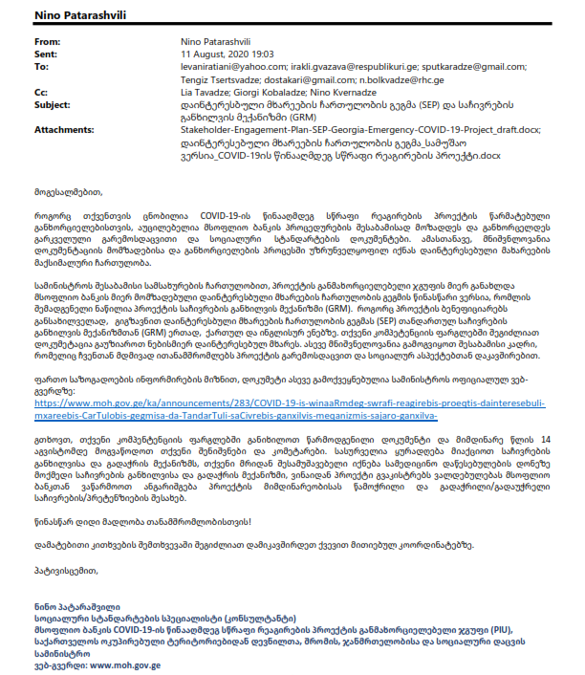
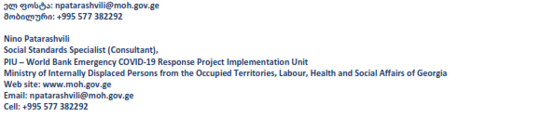
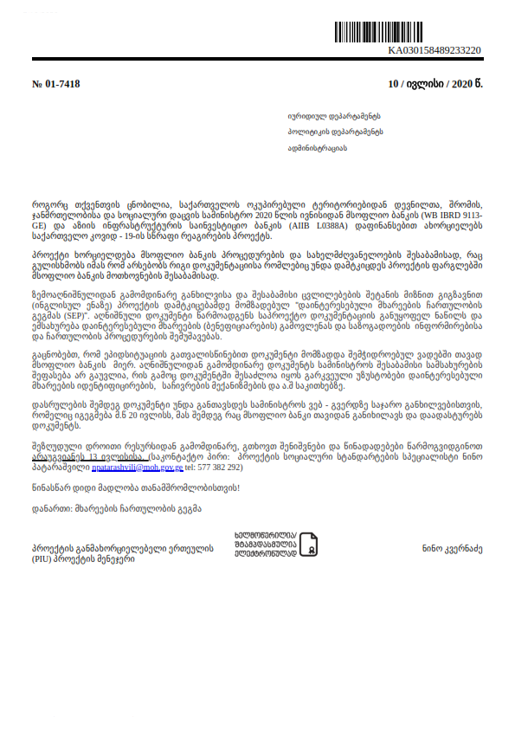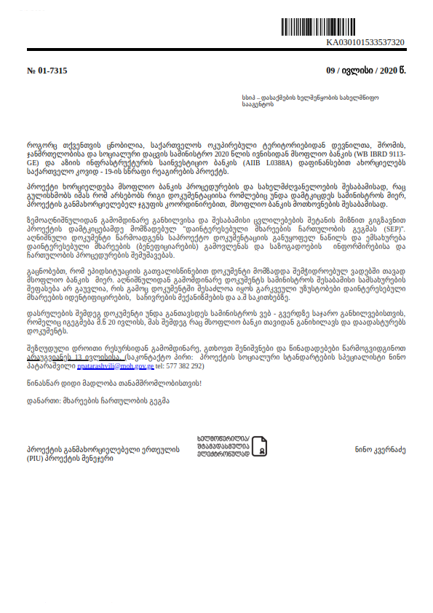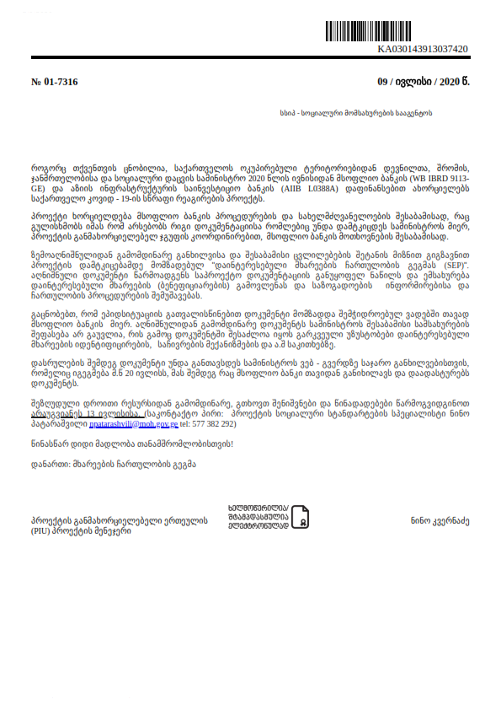

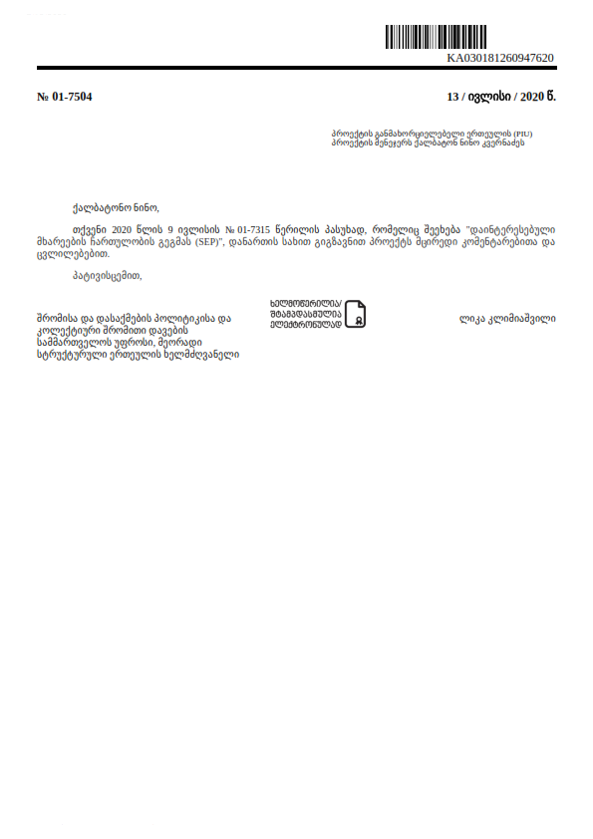
Annex # 2, Reminder and Invitation to the online consultation meeting

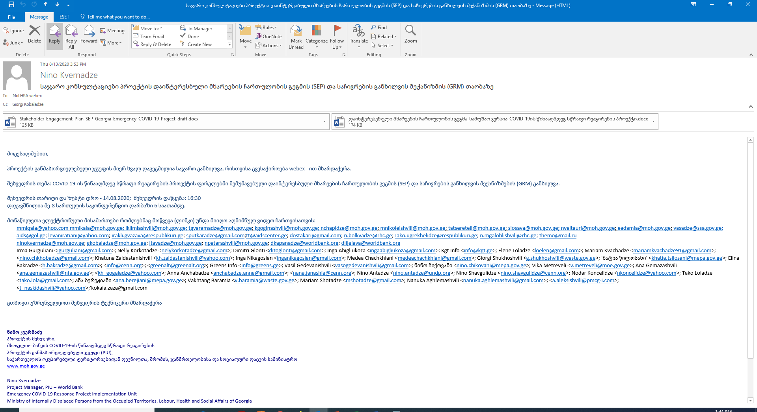
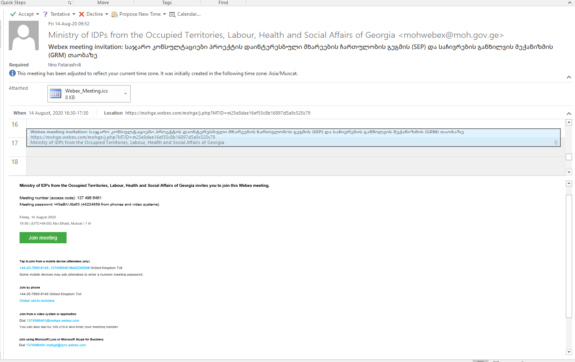
Annex #3, Power Point Presentation
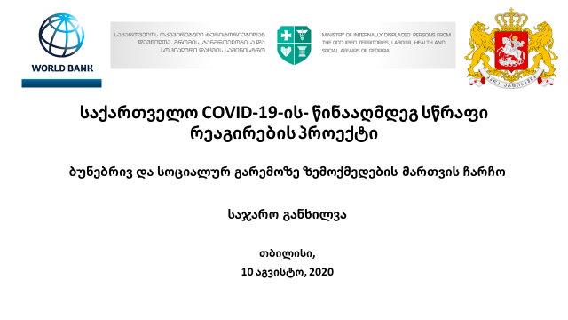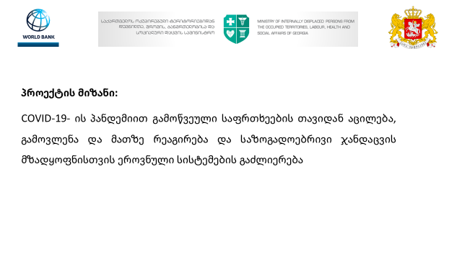
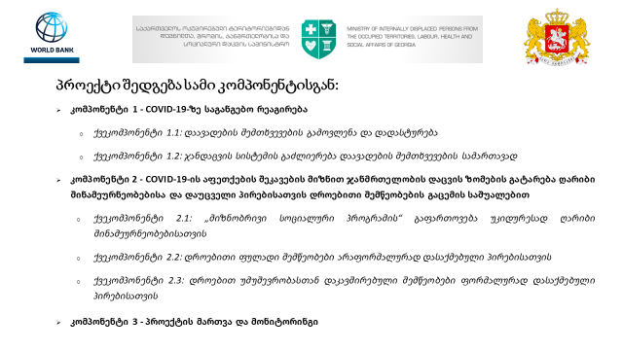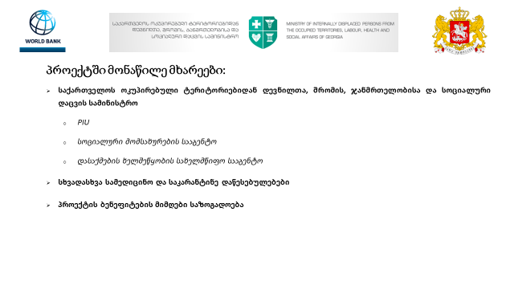

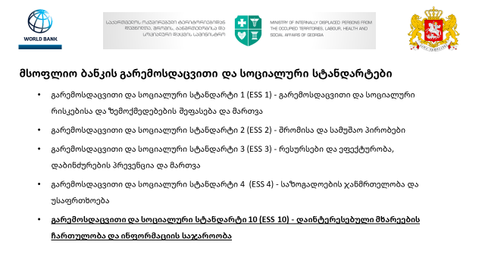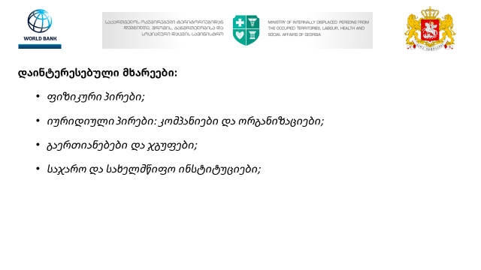

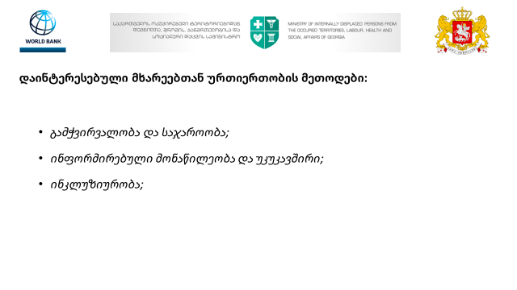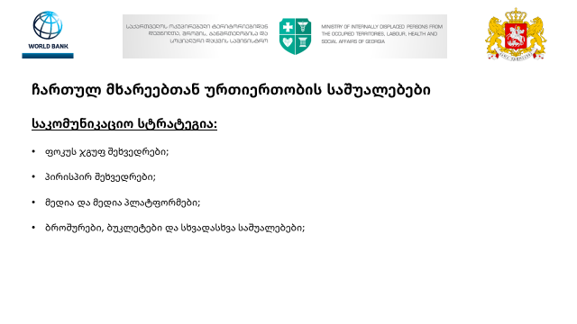
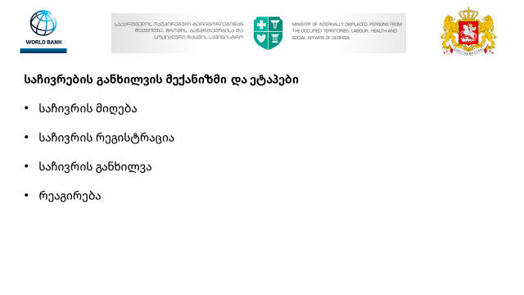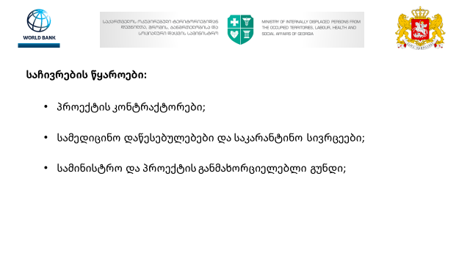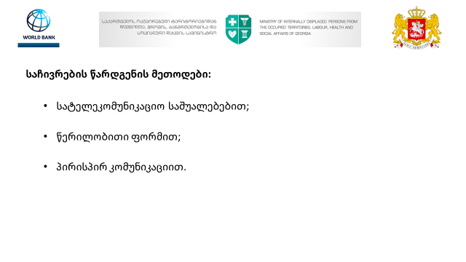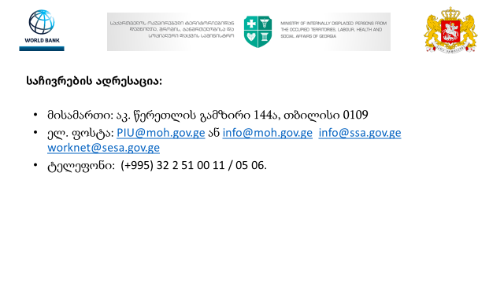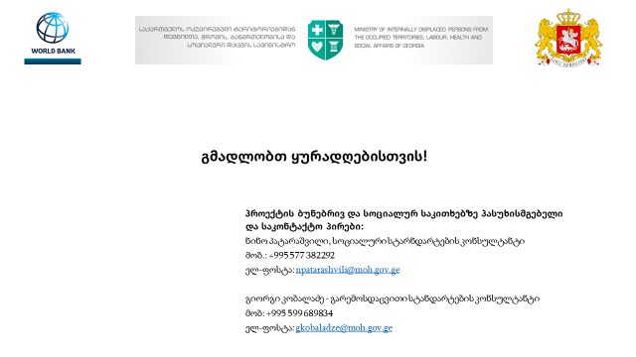

Annex #4, Photo materials
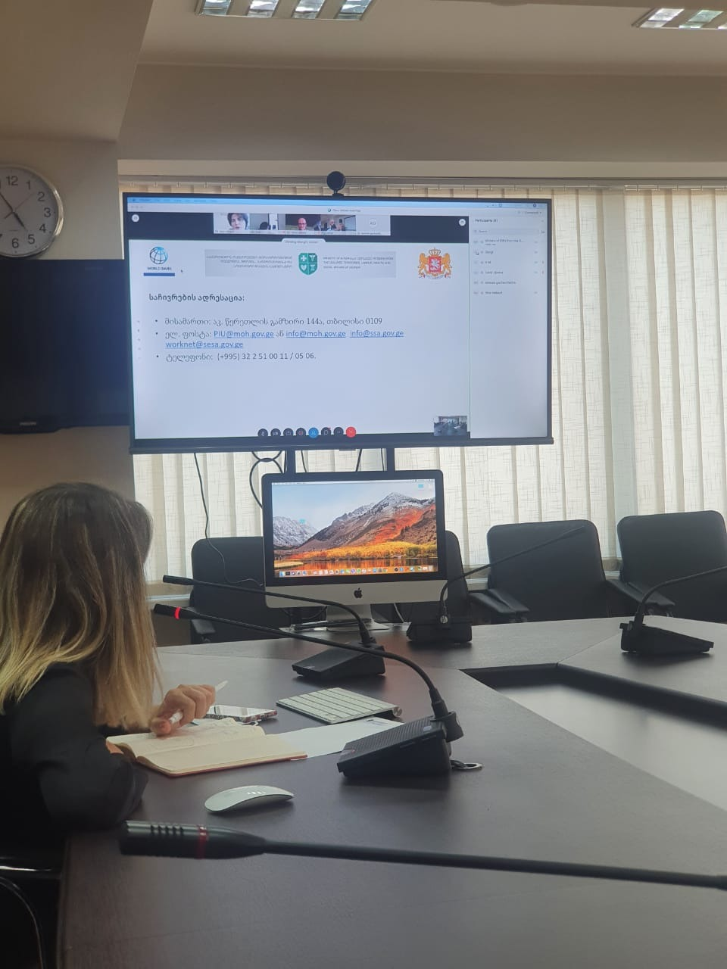

Appendix 3

Communication Action Plan for Introduction of COVID-19 Vaccine in Georgia
- Intoduction
According to the World Health Organization (WHO) the global pandemic COVID-19 has already claimed the lives of hundreds of thousands of people and caused the greatest damage to the health and well-being of billions. The introduction of effective, safe and affordable vaccination is a key precondition to controlling and ultimately ending the pandemic, which, combined with a dramatic reduction in infection-related deaths, would prevent an average monthly loss of $375 billion to the global economy. Fair worldwide access to vaccine, especially for health care workers and those at high risk, is the only way to mitigate the economic impact on health care and the pandemic
Years of experience and evidence from the introduction of new vaccines have proven that clear and effective communication is essential for the successful implementation of a COVID-19 vaccination program, which should be initiated before vaccines become available. Increasing confidence in the vaccine among the general population and especially in the first target groups, as well as dispelling misinformation related to the vaccine, is important to ensure high vaccine uptake. A successful COVID-19 vaccination program, in turn, will have a significant impact on the country's immunization program and routine vaccination coverage in the coming years.

- Communication Challenges, Barriers and Strategies
Communication Barriers and Strategies
Despite great efforts to provide access to the COVID-19 vaccine, acceptance of the vaccine by the public can be very low due to a number of factors, including Misperceptions of disease risk, distrust and hesitancy toward vaccines and institutions (including government, health care system).
Behavioral studies have shown that in addition to public awareness, vaccine acceptance is affected by three factors that need to be considered to understand the problem and determine strategies: 1) enabling environment; 2) social influences; and 3) motivation (Figure 1).

Figure 1: In addition to public awareness, three factors influence vaccine acceptance.
- Creating an enabling environment for vaccines involves reducing barriers and increasing access to the vaccination process, as well as a combination of factors such as:
- Geographic accessibility: is it close by, conveniently located place?
- Financial accessibility: are any costs involved (for the vaccine itself, travelling, or opportunity costs of missing work), either monetary or nonmonetary?
- Time: Is it time-consuming to be vaccinated? Is booking easy and accessible? Are vaccines delivered at a time of day that is convenient?
- Positive vaccination experience: do people feel they are treated with kindness, understanding, and respect? Are health care providers well informed and able to answer questions about COVID-19 and vaccination?
- Information: Have people been given timely, easy to understand and relevant information about what they are supposed to do, how they are supposed to do it, and how they might benefit? Are the benefits and side-effects of the vaccine explained in plain terms?
- Defined target population: Is the default in workplaces to vaccinate all employees, with provision for those who do not want to be vaccinated to opt out? Do health care providers present the opportunity to be vaccinated as the default option?
- Healthcare regulations: Is vaccination mandatory to engage in certain activities, such as employment, education, travelling abroad or enrolling in care of risk-groups?

- Social influences. Lack of favorable social influences and, on the other hand, unfavorable social influences can be a barrier to vaccine acceptance in the society.
- Social norm: Social norms in society, combining common beliefs and behaviors, influence vaccine acceptance and vaccination coverage.
- Media: The media has a major influence in shaping social norms in society. The views of a small but highly publicized group of people on vaccination may often be mistaken by the public for the opinion of the majority. This is especially important during a pandemic when social contacts are reduced, people are isolated in their homes, and perceptions of public opinion and behavior are shaped by information from media and social networks rather than direct interaction.
- Social Network: Vaccination decision-making according to the socio-environmental behavior model (Figure 2) is also influenced by people’s social networks that include family members, friends, healthcare professionals, and others with whom they interact, as well as the sources of information they consult. The research shows that the likelihood of vaccine uptake decreases when a large proportion of people on a social network do not recommend vaccination. Opinions and behaviors can spread through a cascade and by choosing as targets influential people, such as health professionals (or other community leaders) who are more likely to influence vaccination behavior, one can have a greater impact on behavior change efforts.

Figure 2: Social-Ecological Model of Behavior.
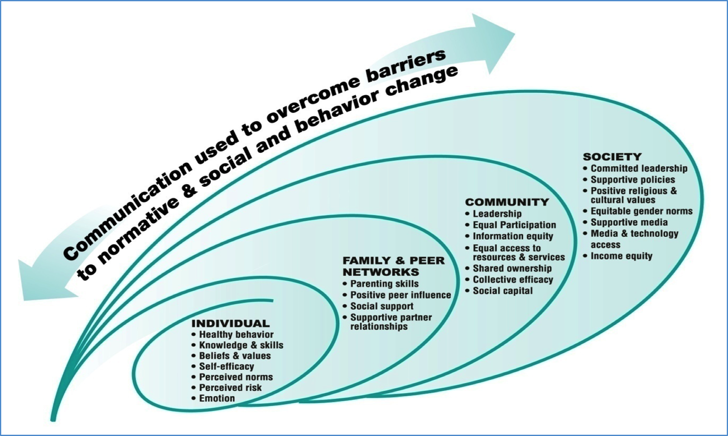

Individual

- Motivation: Motivation to get vaccinated is usually the result of a combination
- of factors, such as perceived risk and severity of infection, confidence (in vaccines, providers, system), values and emotions.
- Risk perception: Perception of risk, and not a scientific assessment of risk, determines a person's behavior. If people perceive that they are at low risk of contracting COVID-19, or that the consequences of becoming infected will not be severe, they will be less willing to get vaccinated. When comparing the risks of disease and a new vaccine, people may find vaccination to be more risky than the disease itself. People are looking for shorter ways and the easiest solution when making behavioral decisions. Because risk is difficult for most people to perceive and evaluate, it is often formed by using "mental shortcuts". For example, people often discuss the probability of events based on how easily they remember such an event ("Accessibility heuristics"). As a result, they may underestimate some risks (e.g., likelihood and consequences of infection) and exaggerate others (e.g., likelihood of side effects after vaccination) based on personal experience or rumors.
According to a quantitative survey conducted in Georgia on September 15, 2020, supported by WHO and the United Nations Children's Fund - Monitoring Behavioral Assessments for the COVID-19 Pandemic Response Report, with a slight change from previous rounds, more than a third of people think they are more likely to be infected with COVID-19, while only 21% believe that if they become infected, the disease will develop into a very severe form.
Perceptions of possible regrets: Risk assessments of events or situations can lead to fear, anxiety, and possible regrets about a decision that has been shown to be associated with vaccination acceptance. Perceptions of possible regrets - when people expect that an unintended outcome in the future will lead them to want to make a different decision in their time - is one of the best indicators of both judgment and behavior prediction.

- Low confidence: Low acceptance of vaccines may be due to low levels of confidence in vaccines, such as a belief that the vaccine will not be effective or that it is accompanied by serious side effects. People may also have low confidence in the system that administers vaccinations, including the competencies of health care workers and the motives of the government (and other stakeholders). Confidence not only in the vaccine, but also in the government is an important factor in vaccine acceptance. People who have less confidence in the country's leadership are much less likely to get vaccinated against COVID-19. Government officials, community leaders, celebrities and family members are encouraged to get vaccinated and to talk openly and transparently about the risks and benefits of the vaccine. According to the aforementioned survey conducted in Georgia, confidence in institutions is quite high, although it has decreased compared to the period of the pandemic onset (May, 2020).

- Infodemic and misinformation: In a rapidly changing epidemic, given the many uncertainties (lack of evidence, knowledge, and experience) regarding COVID-19 vaccines, there is a risk that information deficits will be filled by misinformation.With so much exaggerated information circulating about COVID-19 (also known as "infodemic"), people are likely to be influenced by misinformation, gossip, and false conspiracy theories, which can undermine their confidence in vaccination.

- Expectation management and communication on adverse events following immunization (AEFI): Vaccine acceptance may reduce because of the non-100% efficacy of COVID-19 vaccines, which means that people will have to continue preventive behavior (eg wearing masks and keeping physical distance) even if they are vaccinated. It is important to manage expectations and ensure that vaccinated people do not stop preventive behavior and protect themselves and others from infection.
Due to the lack of experience with COVID-19 vaccines, new vaccines may or may not be correctly attributed to so-called adverse events, so it is important to report adverse events following immunization (AEFI).

- Vaccine Hesitancy: According to WHO, hesitancy is the delay or rejection of vaccination despite the availability of immunization, which ranges from minor concerns to complete rejection of vaccination. There are individual and group differences: some may avoid vaccination because of low confidence in vaccines, low risk perception, vaccine efficacy and/or safety concerns, religious beliefs, or lack of confidence in the Healthcare system.
Hesitancy to COVID-19 vaccination is widespread According to studies and surveys, only 67% of the United States population, 68% of Canada, 75% of Israel, 65% pf ireland and 69% of the United Kingdom agree to be vaccinated against COVID-19. A survey conducted in Georgia shows that, on the recommendation, an average of 57% of the population agrees to be vaccinated against the COVID-19 and only 55% believe that the vaccine will help stop the spread of COVID-19. 22% categorically refuse vaccination, also 36% refused vaccination if they had already had an infection, and 28% refused vaccination if others had been vaccinated. Female respondents were more likely to refuse vaccination. Vaccine acceptance was most associated with high trust in the medical sector and frequency of seeking information. Those who were negatively influenced by the media were more likely to refuse vaccination. The study also found that using the vaccine for the first time in other countries (71%), removing restrictions (60%), recommendations from the Department of Health (68%) and the family physician (64%) were important determinants of vaccine acceptance. According to a December DCJEC online survey, 59% of respondents said they would get the vaccine; 67% said they would get vaccinated an older family member; 65% would do so with a family member who has a chronic disease. 73% believe vaccination should be voluntary.

- Involvement of the target population and dialogue
Before initiating communication, dialogue with the target group is crucial to address specific obstacles and develop strategies. Experience during previous epidemics also underscores the need for ongoing monitoring of community sentiment and needs in order to adapt strategies and policies (29). Involving the target population and local community in the communication process can play an important role in building confidence in the health system, in the process of developing policies and services that respond to and are tailored to local needs.
- To date, the studies on immunization topics conducted in Georgia have only assessed public attitudes and behaviors in the context of child immunization. The target population identified for the first phase and the diverse population identified for the future, if the program is expanded, do not represent the traditional population participating in immunization programs. Consequently, targeted and population-oriented communication strategies as well as management of public expectations are necessary. Thus, it is important to know anti COVID-19 vaccination information and attitudes, conduct behavioral research to develop evidence-based communication strategies and interventions, and gather real-time information on which interventions work and which need to be replaced or changed.
Strategic Communication Directions
International experience and research confirm that information or individual interventions alone are ineffective in overcoming barriers to vaccination and that different strategies and approaches need to be integrated and combined. For example, such as planning reminders and instructions, training health care workers, and building confidence in them.
The Communication Action Plan builds on four interrelated strategic elements of an integrated approach to vaccine demand:

- Social listening, media involvement and disinformation management
- Listening and understanding of target populations, developing targeted communication strategies by collecting behavioral and social data on key factors;
- Creating a supportive and transparent information environment and neutralizing misinformation through social listening and evaluation to plan further interventions.
- Risk communication and community involvement
- Increasing vaccine credibility and acceptance by engaging civil society (including local organizations and communities, especially vulnerable target populations).
- Strengthening health professionals
- Raising the awareness and knowledge of medical staff about COVID-19 vaccination as the first target vaccination group, a trusted source of information, influential persons and vaccinators. In addition, interpersonal communication skills of the target population groups and the community should be strengthened.
- Crisis communication
- Preparedness of the country to manage crisis situations, to respond quickly and in a coordinated manner in the event of post-immunization adverse events(AEFI)at all levels (central and regional).

Figure 3. Four interrelated strategic elements of an integrated approach to vaccine demand

Strategy Goal and Objectives :
Goal
Increasing confidence, acceptance and demand for the COVID-19 vaccine.

The following approaches will be used to achieve the goal: advocacy, communication, social mobilization, risk and safety issues, community involvement, training, crisis communication.
Objectives :
- Mobilize and engage key partners and the community.
- Dialogue with internal and external partners regarding the implementation of the COVID-19 vaccination program to understand their key perspectives and needs.
- Media information, media mobilization and advocacy
- Develop detailed guidelines to COVID-19 Vaccination Technical and Effective Communication and conduct training for local provider medical facility managers, nursing staff and other stakeholders
- Provide constantly updated information to the public on the development, authorization, introduction, distribution and use of COVID-19 vaccines, using a strictly defined communication hierarchy
- Ensuring public confidence in the safety, efficacy and introduction of the COVID-19 vaccine
- Disseminate active, timely, accessible and effective messages on community consolidation, expectations management, public health, safety
- Mobilize the target population of COVID-19 vaccine, as well as conducting effective communication for both first and second dose vaccination invitations.
- Infodemic management and dispelling misinformation
- Monitoring, supervising the strategy implementation process and assessment of the impact

Target Audience and Audience Segmentation:
- Parties involved in the introduction of Covid-19 vaccine
- Coordinating Council
- NITAG members
- Ministry of Health and NCDC
- Regional and district public health centers
- Local government
- Local and international partners
- Medical Service Providers and Staff (Health Sector in full)
- Representatives of high risk groups
- Beneficiaries and staff of a long-term care facility
- Individuals over the age of 55
- Individuals with chronic medical conditions (18-54 years of age)
- Providers of essential services, etc.
- Part of the population not included in the groups defined for the first stages (expectation management).
- Stakeholders / influencers
  - Policy makers and politicians
  - Civil society
  - Scientific Society, Academy
  - NGOs
  - Critical and negative groups
  - Business sector
- Mass media and social media
- Central and regional television (including television stations broadcasting ethnic minority languages)
- Radio
- Printed media
- Social media groups and "influencers"
- STOPCOV.ge
- MOH.gov.ge
- NCDC.ge
- Facebook, Instagram pages
- NCDC
- Covider

Strategy Implementation Phasis and Priority Activities:

Use of timely notifications for the current phase of the COVID-19 vaccination program.
- Before the start of vaccination
- The vaccine is available in a limited number of populations for the designated groups (Phase # 1 - 1-14% of the adult population)
- Health sector in full
- Beneficiaries and staff of a long-term care facilities
- > 75 aged population
- Population aged 65-74
- Essential services and other high-risk groups
- Vaccine availability is increasing for critical population groups and the general population (Phase 2 - 14-26% of the adult population)
    - Population aged 55-64.
    - Population aged 18-54 with a chronic diseases.
- The vaccine is widely available (Phase 3 - 26-60% of the adult population)

Communication Strategy Action Plan for Introduction of Covid-19 Vaccine in Georgia

 | Activities | Description | Communication material/intervention | Distribution channels | Execution Deadline | Evaluation indicators | Responsible party | Required financial resource
Target group1: Parties involved in the introduction of Covid-19 vaccine
Objective1.1. Mobilizing and coordinating parties
Objective 1.2. Increasing competence regarding Covid-19 infection and Covid-19 vaccine
 | Development of a communication strategy and communication materials for the introduction of Covid-19 vaccination | - Development and periodic updating of key communication messages in accordance with the monitoring data.  - Development of evidence-based material about the Covid-19 vaccine (including frequently asked questions, debunking myths | - Message box  - Question-and-answer document for speakers.  - Myths and Facts Document | Between the parties involved in the implementation including during the crisis, interpersonal communication and media training. | 15.01.21 | The document reflects evidence-based information and addresses local challenges | NCDC  Communication group | 0
 | Agreement with the Covid-19 Working Group on the Communication Action Plan and Working Versions of the Communication Material | Discussion of communication strategy and communication materials with the working group (including NITAG members) and introducing changes based on their feedback (if necessary) | Working meeting. | By email in a working group. | 14.01.21 | Number of meetings | NCDC-Communication Group | 0
 | Mobilization of speakers(leading infectious disease specialists, public health experts, immunologists, primary care physicians, regional public)and organizing a working meeting on communication issues | - Objective: To get acquainted with the communication strategy, action plan and materials developed, to develop effective cooperation mechanisms, to participate in the formation of messages, to review and discuss their role in the communication field of vaccination. Based on the feedback received and with the involvement of the WHO Invited Representative, develop a final action plan and materials.  - Make a list  - Develop a meeting agenda  - Prepare presentations  - Invitation  - Printing meeting materials | Working meeting.  List of speakers | By email in a working group. | 18.01.21 (The frequency of further meetings will be determined as needed) | Number of meetings | NCDC-Communication Group | 0
 | Development of a crisis communication plan | Developing a detailed mechanism for coordination and timely dissemination of accurate information among the parties in the event of COVID-19 vaccine adverse effects or other crises and reaching an agreement with relevant agencies  - • Development of standard operating procedures (SOP)  - • Develop a real-time rapid detection and response guide to rumors, myths and misinformation  - • Translation of guidance documents ((1) VACCINE MISINFORMATION MANAGEMENT FIELD GUIDE, (2) Debunking Handbook 2020 (3) Vaccine Safety Events: managing the communications response)  - • Develop key messages and deliver coordinated and rapid dissemination to ensure one-on-one conversation with immunization providers and stakeholders.  - • Communication with the affected population and other target audiences in the case of AEFI. | Crisis communication plan, guidelines and crisis communication message box | Distribution at seminars and trainings and posting on the website. | 29.01.21 | The document reflects evidence-based information and addresses local challenges | NCDC-Communication Group | 4500
 | Crisis communication trainings | A training module will be developed and training will be provided for local healthcare professionals, provider clinic managers, and potential and identified speakers / leading specialists (who are considered potential speakers) in crisis communication.  Topics:  - Principles of public health crisis management and risk communication  - Advocating for the importance of vaccines, developing and disseminating messages for behavior change.  - Relations with media  - Involvement and interaction in social media  - Infodemic and disinformation  - Dealing with vaccine antagonist active groups  A total of 15 trainings - persons responsible for immunization of public healthcare centers (75 trainees), providers' clinic managers (60 trainees), speakers (30 trainees) and influencers (10 trainees) (175 trainees in total) | Crisis Communication Training Module and Learning Materials | Online trainings and working meetings | 29.01.21 | - Number of participants  Brief evaluation survey | NCDC-Communication Group | * See the training cost in the appropriate section.
 | Organizing a press conference on the introduction of vaccination against Covid-19 and media coverage | Will be organized by the Ministry of Health and the NCDC, where information about the introduction of Covid-19 vaccination will be provided to the general public.  - List of participants  - Invitation.  - Develop an agenda.  - Prepare presentations  - Invitation of media | - Press release  Presentation material | Television, social media and the web | XX.02.21  * To be specified according to the date of introduction. | - Number of media channels | NCDC-Communication Group | 0
 | Strengthen social listening and public communication mechanisms and capacity building on Covid-19 vaccinations | - Develop and share frequently asked FAQs document for the Ministry, as well as for NCDC and hotline operators for the general populationCOVID-19  - Informing hotline operators about vaccination issues  Summarize the questions received by the hotline managers and share them in the communication group | 1. Question-answer document for the general population  2. Myths and Facts Document .  3. List of vaccination providers  - 4. Working meeting | Working meeting, web site and social page | XX.02.21  * To be specified according to the date of introduction. | - The document reflects evidence-based information and addresses local challenges | NCDC-Communication Group | 0
 | Supervisory support | - Develop supervisory support tools by the NCDC Communication group and (identify and address challenges on the ground) - facilitate primary and secondary vaccination. | Supervisory Support Tools. | On-site visits / working meetings with stakeholders. | In a month after initiation of vaccination |  | NCDC-Communication Group | 37500
 | Monitoring and evaluation of the strategy | Translate and adapt the monitoring and evaluation framework and Quantitative (KAP survey) and qualitative (focus groups and in-depth interviews) audience research | WHO Framework Document  Research report | On the Center website and during working meetings | * To be specified according to the date of introduction. |  | NCDC-Communication Group | 101500
 | Consultation and cooperation with WHO | - Organizing workshops with WHO Immunization Communication Expert Group. | Recommendation document | Online working meetings | 5.01.21 (Completed) | - Number of meetings and participants | NCDC-Communication Group | 0
2 target group: medical staff
Objective 2.1. Raise awareness of Covid-19 infection and the Covid-19 vaccine

Objective 2.2. Improve interpersonal communication skills to promote Covid-19 vaccine
 | Constant updating of the existing COVID-19 website | - Increasing access to reliable information on the Covid vaccine in the Georgian, Armenian and Azerbaijani languages in order to dispel myths and rumors about the Covid vaccine  - Posting evidence-based material on Covid-19 vaccination (for medical staff, in the Georgian, Armenian and Azerbaijani languages on the website and Facebook page;  - Developing and posting frequently asked questions and answers based on WHO materials, in which the user will find answers to a lot of misinformation/myths;  - Preparing and publishing information about reliable internet resources on the website | 1. Resolutions, SOPs, posting guidelines.  2 Questions and answers for speakers.  3. Myths and Facts document.  Posting of information. | STOPCOV.ge  MOH.gov.ge  NCDC.ge  Facebook | XX.02.21  * To be specified according to the date of introduction. | - Fulfillment within the specified timelines. | NCDC-PR service and Communication Group
 | Interpersonal communication training with providers and providing information materials to medical staff to increase their knowledge and distribute it to the population | Training topics:  - Fundamentals of behavioral science defining vaccine acceptance interventions  - Interpersonal communication (including AEFI communication)  - Advocate for the importance of the vaccine and develop and disseminate behavioral change messages  - Dealing with active groups against the vaccine  - Infodemic and misinformation  - Involvement and interaction in social media  - The training also includes messages for physicians, the risk groups and general population, and the responsibilities and rights of medical staff involved in immunization.  - The trainings should emphasize and send a clear message that all vaccines imported to Georgia are of "high quality" regardless of cost and country of manufacture, and that all vaccines imported into the country are tested in the same way and are pre-qualified by WHO.  - Translation of training material  - Training plan  - Development of training materials  - 80 trainings (1200 participants)  - Dissemination of training materials | Training module and materials | On-site / online trainings | XX.02.21  * To be specified according to the date of introduction. | - Pre- and post-test evaluation  - Number of participants  - Evaluation Questionnaire | NCDC-Communication Group | * See the training cost in the appropriate section
 | Develop talking points, video clips and presentations about the Covid-19 vaccine and conduct webinars for medical staff. | - Preparation of video and electronic materials for medical staff and posting of the developed material on the website. The developed material will be posted on the website. | Video clips  Webinars | Posting on the website and social media | XX.02.21  * To be specified according to the date of introduction. | - The document reflects evidence-based information and addresses local challenges | NCDC-Communication Group | 10000
3. Target group: representatives of high-risk groups (beneficiaries and staff of a long-term care facility; people over 50; people with disabilities (18-49 years old); providers of essential services, etc.,high-risk groups
Objective 3.1. Increase awareness of Covid-19 infection and the Covid vaccine
Objective 3.2 Increase the number of visits to vaccination specialists
- ს1. | Summoning for vaccination with the first dose and revaccination incl. in a format acceptable to national minorities and persons with disabilities | - Telephone communication and SMS messages by Providers(NCDC)  - Activation of immunization module / mobile application / electronic certificate  - Preparing and printing memory cards | SMS texting  Memory cards | Mobile phone, distribution in medical facilities. | XX.02.21  * To be specified according to the date of introduction. | - The document reflects evidence-based information and addresses local challenges | NCDC-Communication Group | 13500
- 2. | Develop and distribute Covid-19 infection and vaccine information materials (brochures, posters) | რისკ-ჯგუფის Pre-printed communication materials written in simple language will be developed and distributed in advance , providing answers to frequently asked questions and urging to get vaccinated against Covid.  Preparation and printing of one-page printed communication material / booklet of A5 format, 100 000 pcs.  Preparation and printing of A2 posters (300-gram, visual material for distribution in primary healthcare centers, clinics. Material should include facts about the vaccine, possible risks after infection with Covid-19, the importance of prevention and the call for vaccination)  Posters for will be prepared for distribution in primary healthcare centers clinics  2,000 pcs.  Materials will be tested with at-risk groups before being printed.  - Development  - Adapting  - The development of tender documents.  - Testing  - Development of design and testing  - Preparing question and answer document. | Information booklet and poster | - At Trainings,  - In Regional public health center / by volunteers in medical facilities  - In primary care clinics in the doctor's office  Electronic versions are uploaded to the website and social media page. | XX.03.21  * To be specified according to the date of introduction. | - The document reflects evidence-based information and addresses local challenges | NCDC-Communication Group | 10800
- 3 | Providing risk groups (including vulnerable groups) with competent advice and information materials | (1) With the help of training and information materials provided for public health, primary care physicians, and nurses, they will be able to provide counseling on the Covid vaccine for risk groups and the general population.  (2) Identify contact persons for local social services. Organizing a meeting with them (online or in person). Providing group-tailored, important information to them for further dissemination. Carrying out Outreach interventions to mobilize the public and provide information. | Working meetings and Outreach Interventions | Online working meetings | XX.03.21  * To be specified according to the date of introduction. | - The document reflects evidence-based information and addresses local challenges | NCDC-Communication Group | 0
4 Target group: interested parties/influential stakeholders (civil society, academia, relevant NGOs, etc.)
Objective 4.1. Raise awareness of COVID-19 infection and the vaccine
Objective 4.2. Support and/or advocacy for COVID-19 during the holiday period
Objective 4.3. Community mobilization
 | Increase access to scientific information | - Prepare a collection of evidence-based materials, including thematic scientific articles from trusted medical journals, which will be provided to all stakeholders, including medical staff, during trainings, webinars, and will be posted on the website and in scientific blog posts. | Collection of Evidence-Based Materials | Trainings, webinars,  In the form of websites and scientific blog posts. | XX.02.21  * To be specified according to the date of introduction. | - The document reflects evidence-based information and addresses local challenges | NCDC-Communication Group | 0
 | Cooperation with organizations and activists working with people with disabilities | Identify organizations and activists working with the disabled community, work with them (online or face-to-face), provide TOT trainings, inform them, and disseminate strategy-driven messages through their communication channels.  - 10 meetings in total (150 listeners) | Webinars, materials for working meeting / seminars including. on vaccination issues in the community with disabilities | Online working meetings | XX.01.21  * To be specified according to the date of introduction. | -Evaluation questionnaire  - -Number of listeners | Community leader and NCDC-Communication Group | 0
 | Cooperation with celebrities and influencers | - Identifying public figures, influencers, having working meetings and gaining public support to covid vaccination as a means for strengthening and protecting at-risk groups, in order to gain public confidence and to increase the credibility of covid vaccination. | Working meeting / webinar | Online working meetings | XX.02.21  * To be specified according to the date of introduction. | -Evaluation questionnaire  - -Number of listeners | NCDC PR Service and NCDC Communications Group | 0
 | Informing and involving the scientific community | Identifying and meeting( online or face-to-face) medical associations and sharing the materials they need. Two meetings with listener participation (50)  - Meeting with administrators of public and private institutions of higher and vocational education (online or face-to-face) and sharing necessary materials for lecturers. | Working meeting / webinar | Online working meetings | XX.01.21  * To be specified according to the date of introduction. | - Number of listeners | NCDC PR Service and NCDC Communications Group | 0
 | Involvement of the private sector mobilization and communication with public | - Identifying representatives of the private sector. Organizing a meeting with them (online or in person). Providing group-tailored, important information to them for further dissemination. | Working meeting / webinar | Online working meetings | XX.02.21  * To be specified according to the date of introduction. | - Number of listeners | NCDC PR Service and NCDC Communications Group | 0
 | Mobilization of ethnic and religious minority communities | - Identifying local civil society leaders and religious leaders, meeting with them (online or face-to-face), informing them, and disseminating strategy-based messages through their communication channels with the support of the National Agency for Religion. | Working meeting | Online working meetings | XX.02.21  * To be specified according to the date of introduction. | - Number of listeners | NCDC PR Service and NCDC Communications Group | 0
 | Information meeting with the leaders of the Orthodox Church | - Meeting with representatives of the Patriarchate and influential clergy. and providing information to them | Working meeting | Online working meetings | XX.02.21  * To be specified according to the date of introduction. | - Number of listeners | NCDC PR Service and NCDC Communications Group | 0
 | Mobilization of volunteers, training and delivering materials | - Mobilization of volunteer groups in collaboration with NGOs, community and youth organizations to disseminate information and communication materials. | Working meeting, webinar and Outreach interventions | Online working meetings | XX.03.21  * To be specified according to the date of introduction. | - Number of people reached through meetings and Outreach interventions | NCDC Communications Group | 0
5 Target group: Mass Media and Social Media (Facebook, twitter, Wordpress, Linkedin, etc.)
Objective 5.1. Raising awareness of Covid-19 infection and Covid vaccine
Objective 5.2. Covid Vaccine Support
 | Increase media access to Covid-19-vaccination issues | Access of media to eliable sources of information, speakers who provide verified and accurate information through the media team.  Media support of the campaign is needed to inform the general public in a short period of time. For example:  - those who will talk about vaccination in general and the Covid vaccine in particular  - Providing media with information materials / positive stories..  - Preparation of messages to be disseminated in the media and broadcasting , incl. focusing on the importance and quality of vaccine, prevention of Covid-19 infection by health care leaders.  Particular attention should be paid to thoroughly explaining:  1. Why is vaccination given only to medical staff and risk group members;  2.Two stages of vaccination and the need for a second vaccination  3. Organizing a visit of the Patriarchate on television and  preparing stories for promotion;  4.In those TV shows in which representatives of religious denominations participate  - 5. Using the regional broadcast channels (including media channels broadcasting in the language of ethnic minorities). | Frequently Asked Questions (FAQ), Reasoned Information, Materials for responding to Myths and rumors | Through trainings, webinars and posting on a website / social media page | XX.02.21  * To be specified according to the date of introduction. | - The document reflects evidence-based information and addresses local challenges | NCDC PR Service and NCDC Communications Group | 0
 | Media trainings | - Information meeting with the media - planning and conducting media trainings 20 trainings during the year | Presentation material | Online training-working meeting, traditional and internet media channels. | XX.XX.21  * To be specified according to the date of introduction. | The document reflects evidence-based information and addresses local challenges  - Coverage via media channels and population access. | NCDC PR Service and NCDC Communications Group | * Cost of media training in the relevant section.
 | Media Advocacy | • Develop and update a media plan  • Development of video and audio materials for the target audience in Georgian, Azerbaijani and Armenian languages  • Organizing programs / visits on central and regional TV and radio channels  • Print articles  • Prepare daily interviews and stories  • Submit and cover the prepared action plan  • Prepare and cover press conferences  • Activate the Center website  • Activate the center's Facebook page, posting posters, videos and updated information  • Plan and conduct media trainings throughout the year  • Conduct research on several rated Internet portals | Training Module, Media Plan,video clip | Online training-working meeting, traditional and internet media channels. | XX.02.21  * To be specified according to the date of introduction. | The document reflects evidence-based information and addresses local challenges  - Coverage via media channels and population access. | NCDC PR Service and NCDC Communications Group | 163 200  * Cost of media training in the relevant section.
 | Media monitoring and anti-disinformation actions | Media monitoring by the Ministry of Health and NCDC on vaccination issues for further timely response.  • Local  • International (CNN, BBC)  • Russian (especially watched by ethnic minorities)  Monitoring the activity of anti-vaccination groups (including social media).  Prepare reliable source-based responses to respond to voiced arguments in collaboration with fact checkers  Trainings to study various technological and methodological approaches in the field of media monitoring and media literacy, including  - Primary healthcare physicians  - Public healthcare specialists  - Local government  - Local leaders  - - Youth | • Media monitoring plan  • Methodological manuals  • Training modules | Website | XX.02.21  * To be specified according to the date of introduction. | The document reflects evidence-based information and addresses local challenges  - Coverage via media channels and population access. | NCDC PR Service and partner otganizations | 0
 | Social media campaign | Development of a social media campaign strategy (concept, branding, design, action plan).  Preparation of video clips  Dissemination of evidence-based information through publications, infographics, blogs and vlogs, and advertising implementation (8 months)  Once a month Integrated live broadcast about COVID-19 on NCDC social media platforms Answering questions about the vaccine by health professionals (infectious disease specialist, clinician, public health specialist, etc.). | Strategic document of the social media campaign and video clip | Social media campaign through Facebook page. | XX.02.21  * To be specified according to the date of introduction. | Materials reflects evidence-based information and addresses local challenges  - Access to publications and level of engagement. | NCDC PR Service and partner otganizations | 27000
 | Advertising | - Placing ads on TV  Placing clips on the radio  Advertising banner placement on the internet portal  - Advertising on Facebook |  | High rating traditional and online media channels | XX.02.21  * To be specified according to the date of introduction. | Materials reflects evidence-based information and addresses local challenges  - Access to publications and level of engagement. | NCDC PR Service and partner otganizations | 1,262,000
 |  |  |  |  |  |  | Total: | 1,662,800

Decree #2459 of the Government of Georgia on the Establishment of the Interagency Coordination Commission for the Implementation of COVID-19 Vaccination in Georgia, December 15, 2020
WHO EUL/PQ evaluation process’ and respective database https://extranet.who.int/pqweb/sites/default/files/documents/Status_COVID_VAX_17March2021_0.pdf
Government Order No67: COVID-19 Vaccine National Deployment Plan: https://www.matsne.gov.ge/ka/document/view/5084798?publication=0
MoILHSA Minister Order No01-11ნ COVID-19 Vaccine National Deployment Plan and Immunization Management Rules https://www.matsne.gov.ge/document/view/5094063?publication=1
Strategic Preparedness and Response Program: https://documents.worldbank.org/en/publication/documents-reports/documentdetail/882781602861047266/world-covid-19-strategic-preparedness-and-response-program-sprp-using-the-multiphase-programmatic-approach-mpa-project-additional-financing
With a score of less than 65,000.
The average monthly TSA transfer is estimated to be 283 GEL per household, nearly three quarters of their average aggregate monthly consumption, estimated at 384 GEL (Household Income and Expenditure Survey 2018, Geostat).
Vulnerable status may stem from an individual’s or group’s race, national, ethnic or social origin, color, gender, language, religion, political or other opinion, property, age, culture, literacy, sickness, physical or mental disability, poverty or economic disadvantage, and dependence on unique natural resources.
https://www.moh.gov.ge/en/announcements/282/Public-Consultation-on-Draft-Stakeholder-Engagement-Plan-including-Grievance-Redress-Mechanism-for-the-Emergency-COVID-19-Response-Project
In case any prolongation of the program, the portal https://compensation.moh.gov.ge will be activated
Behavioural considerations for acceptance and uptake of COVID-19 vaccines: WHO technical advisory group on behavioural insights and sciences for health, meeting report, 15 October 2020 https://apps.who.int/iris/handle/10665/337335
Cialdini RB, Demaine LJ, Sagarin BJ, Barrett DW, Rhoads K, Winter PL. Managing social norms for persuasive impact. Social Influence. 2006;1:3-15. doi:10.1080/15534510500181459.
Lewandowsky S, Ecker UKH, Seifert CM, Schwarz N, Cook J. Misinformation and its correction: continued influence and successful debiasing. Psychol Sci Public Interest. 2012;13:106–31.doi:10.1177/1529100612451018.
Rimal RN, Storey JD. Construction of meaning during a pandemic: the forgotten role of social norms. Health Commun. 2020:1–3. doi:10.1080/10410236.2020.1838091.
Brunson EK. The impact of social networks on parents’ vaccination decisions. Pediatrics. 2013;131(5):e1397–404. doi:10.1542/peds.2012-2452.
Kim DA, Hwong AR, Stafford D, Hughes DA, O’Malley AJ, Fowler JH, et al. Social network targeting to maximise population behaviour change: a cluster randomised controlled trial. Lancet. 2015;386(9989):145–53. doi:10.1016/S0140-6736(15)60095-2.
Weinstein ND, Kwitel A, McCaul KD, Magnan RE, Gerrard M, Gibbons FX. Risk perceptions: assessment and relationship to influenza vaccination. Health Psychol. 2007;26(2):146–51.doi:10.1037/0278-6133.26.2.146.
Betsch C, Böhm R, Chapman GB. Using behavioral insights to increase vaccination policy effectiveness. Policy Insights Behav Brain Sci. 2015;2(1):61–73. doi:10.1177/2372732215600716.
Chapman GB, Coups EJ. Emotions and preventive health behavior: worry, regret, and influenza vaccination. Health Psychol. 2006;25(1):82–90. doi:10.1037/0278-6133.25.1.82.
Brewer NT, Chapman GB, Gibbons FX, Gerrard M, McCaul KD, Weinstein ND. Meta-analysis of the relationship between risk perception and health behavior: the xample of vaccination. Health Psychol. 2007;26(2):136–45. doi:10.1037/0278-6133.26.2.136.
Betsch C, Böhm R, Chapman GB. Using behavioral insights to increase vaccination policy effectiveness. Policy Insights Behav Brain Sci. 2015;2(1):61–73. doi:10.1177/2372732215600716.
Tversky A, Kahneman D. Judgment under uncertainty: heuristics and biases. Science. 1974;185(4157):1124–31. doi:10.1126/science.185.4157.1124.
Tversky A, Kahneman D. Availability: a heuristic for judging frequency and probability. Cognitive Psychology. 1973;5:207–32. doi:10.1016/0010-0285(73)90033-9.
Bish A, Yardley L, Nicoll A, Michie S. Factors associated with uptake of vaccination against pandemic influenza: a systematic review. Vaccine. 2011;29(38):6472–84. doi:10.1016/j. vaccine.2011.06.107.
Godinho CA, Yardley L, Marcu A, Mowbray F, Beard E, Michie S. Increasing the intent to receive a pandemic influenza vaccination: testing the impact of theory based messages. Prev Med. 2016;89:104–11. doi:10.1016/j.ypmed.2016.05.025.
Weinstein ND, Kwitel A, McCaul KD, Magnan RE, Gerrard M, Gibbons FX. Risk perceptions: assessment and relationship to influenza vaccination. Health Psychol.2007;26(2):146–51. doi:10.1037/0278-6133.26.2.146.
MacDonald NE, SAGE Working Group on Vaccine Hesitancy. Vaccine hesitancy: definition, scope and determinants. Vaccine. 2015;33(34):4161–4. doi:10.1016/j.vaccine.2015.04.036.
Sadique MZ, Devlin N, Edmunds WJ, Parkin D. The effect of perceived risks on the demand for vaccination: results from a discrete choice experiment. PLoS One. 2013;8(2):e54149. doi: 10.1371/journal.pone.0054149.
Vinck P, Pham PN, Bindu KK, Bedford J, Nilles EJ. Institutional trust and misinformation in the response to the 2018–19 Ebola outbreak in North Kivu, DR Congo: a population-based survey. Lancet Infect Dis. 2019;19(5):529–36. doi:10.1016/s1473-3099(19)30063-5.
Jamison AM, Quinn SC, Freimuth VS. “You don’t trust a government vaccine”: narratives of institutional trust and influenza vaccination among African American and white adults. Soc Sci Med. 2019;221:87–94. doi:10.1016/j. socscimed.2018.12.020.
Brewer NT, Cuite CL, Herrington JE, Weinstein ND. Risk compensation and vaccination: can getting vaccinated cause people to engage in risky behaviors? Ann Behav Med. 2007;34(1):95–9. doi:10.1007/BF02879925.
Dubé E, Laberge C, Guay M, Bramadat P, Roy R, Bettinger JA. Vaccine hesitancy: an overview. HumVaccin Immunother. 2013;9(8):1763–73. doi:10.4161/hv.24657.
Larson HJ, Cooper LZ, Eskola J, Katz SL, Ratzan S. Addressing the vaccine confidence gap. Lancet. 2011;378(9790):526–35. doi:10.1016/S0140-6736(11)60678-8.
Malik, A.A., McFadden, S.M., Elharake, J., & Omer, S.B. Determinants of COVID-19 vaccine acceptance in the US. medRxiv (2020).
Concerns about COVID-19 — A view from Canada — Coronavirus (Covid-19) researches. Accessed August 10, 2020. https://researchchoices.org/covid19/findings/report/41/concerns-about-covid-19-april-13-2020
Dror, A., et al. Vaccine Hesitancy: The next challenge in the fight against COVID-19. European Journal of Epidemiology 35 (2020).
Murphy, J., et al. Preparing for a COVID-19 vaccine: Identifying and psychologically profiling those who are vaccine hesitant or resistant in two general population samples. PsyArXiv (2020).
Guidance on developing a national deployment and vaccination planning for COVID-19 vaccines, 16 November 2020. Geneva: World Health Organization; 2020 https://www.who.int/ publications/i/item/WHO-2019-nCoVVaccine_deployment-2020.1
Brewer NT, Chapman GB, Rothman AJ, Leask J, Kempe A. Increasing vaccination: putting psychological science into action. Psychol Sci Public Interest. 2017;18(3):149–207. doi:10.1177/1529100618760521.
Harvey H, Reissland N, Mason J. Parental reminder, recall and educational interventions to improve early childhood immunisation uptake: a systematic review and meta-analysis. Vaccine. 2015;33(25):2862–80. doi:10.1016/j.vaccine.2015.04.085.
Brewer NT, Hall ME, Malo TL, Gilkey MB, Quinn B, Lathren C. Announcements versus conversations to improve HPV vaccination coverage: a randomized trial. Pediatrics. 017;139(1):e20161764. doi:10.1542/peds.2016-1764.
Gagneur A. Motivational interviewing: a powerful tool to address vaccine esitancy. Can Commun Dis Rep. 2020;45(4):93-97. doi:10.14745/ccdr. v46i04a06.

